**AWS DOCUMENTATION**

**SpringBoot, S3, EC2, Code Deploy, Code Pipeline project**

**1. Creating your SpringBoot Application** 2

**2. Creating AWS Credentials** 3

**3. Creating IAM Roles** 3

**4. Creating a S3 Bucket** 4

**5. EC2** 8

**6. Code Deploy** 14

**Creating a Code Deployment Group** 16

**7. Creating a Code Pipeline** 20

**8. Installing java 17 sdk and checking the setup** 29

**APPENDIX** 31

**A. Configure IAM Roles** 31

**B. EC2Role** 33

**C. CodeDeployRole** 35

**D. Required Files and scripts** 37

**E. Modifying Application code and re-deploy, re-pipeline** 38

# **1. Creating your SpringBoot Application**

**Gradle-SpringBoot--DynamoDB-Multimodule Deploying in AWS Using IAM Roles, S3 Bucket, EC2 Instance, Code Build, Code Deploy & Code Pipeline (Java 17 Version)**

If you have access to the Gradle-SpringBoot-Dynamo-Multimodule project, it can be used as a starting point for this project. Clone this project into your workspace. Then create a zip file of the project from the root directory of the project. This project requires a dynamodb Orders table be setup to run correctly. It should be setup so that it looks like:

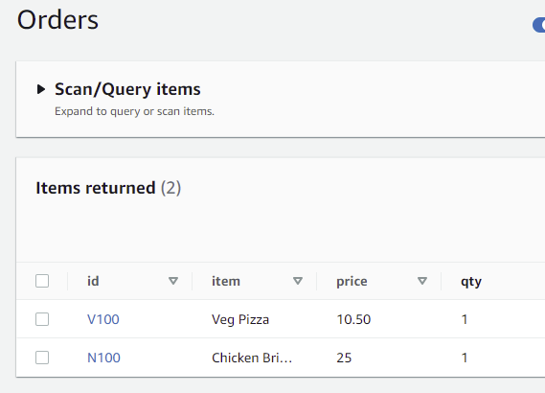

Alternatively, you can create a new project. Create a springboot application using <https://start.spring.io/> . Add dependencies for Lombok, Web, and DynamoDB. A zip file will be created and can alternately be used for this project. This will require a dynamdodb table to work correctly. Also, the spring boot app should have CRUD functionality.

There are 5 required files that need to be added to the application zip file. An appspec.yml file and a scripts folder with 4 files. Refer to the Appendix RequiredFiles for the names and content of the required folders and files.

Note: Try to use the same or similar names for your application, bucket, deployment, and pipeline names so that it will be easy to remember or select for the fields within AWS.

Add the appspec.yml file and scripts folder into the root directory of the project. The folder and file names should be lower case.

The project structure should look similar to the following if you are using the Gradle-SpringBoot-Dynamo-Multimodule project. Note the scripts folder and appspec.yml file in the application zip file.

Project Structure

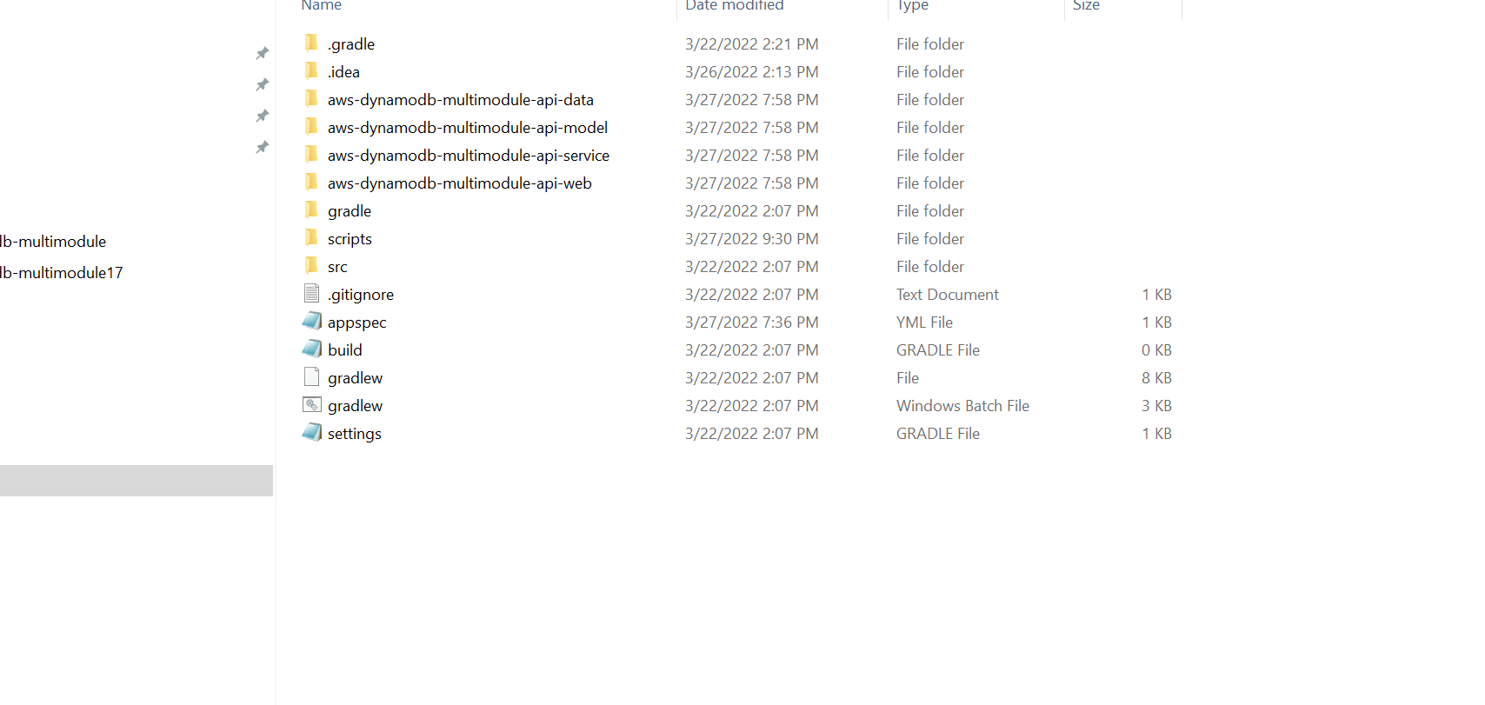

# **2. Creating AWS Credentials**

In order to access AWS and create roles, buckets, dynamoDB tables, you will have to provide your AWS credentials. If you do not have these, please refer to the AWS documentation [IAM Access keys](https://docs.aws.amazon.com/IAM/latest/UserGuide/id_credentials_access-keys.html) in setting these up. Ie: aws_access_key and aws_secret_access_key

# **3. Creating IAM Roles**

To deploy and run this project, the following roles Ec2CodeDepl and CodeDeployRole will need to be created in AWS (if they don’t exist). To create these roles, please see the section, Configure IAM Roles in the Appendix.

If you have your AWS Credential and the IAM Roles created go to <https://console.aws.amazon.com>  in order login to AWS (if needed) and create an AWS bucket containing the application zip file (Step 1).

# **4. Creating a S3 Bucket**

Goto AWS services, type in S3, and select the S3 link This will to AWS Amazon S3 where you can create a bucket which will contain your application zip file.

Click on the Create bucket button.

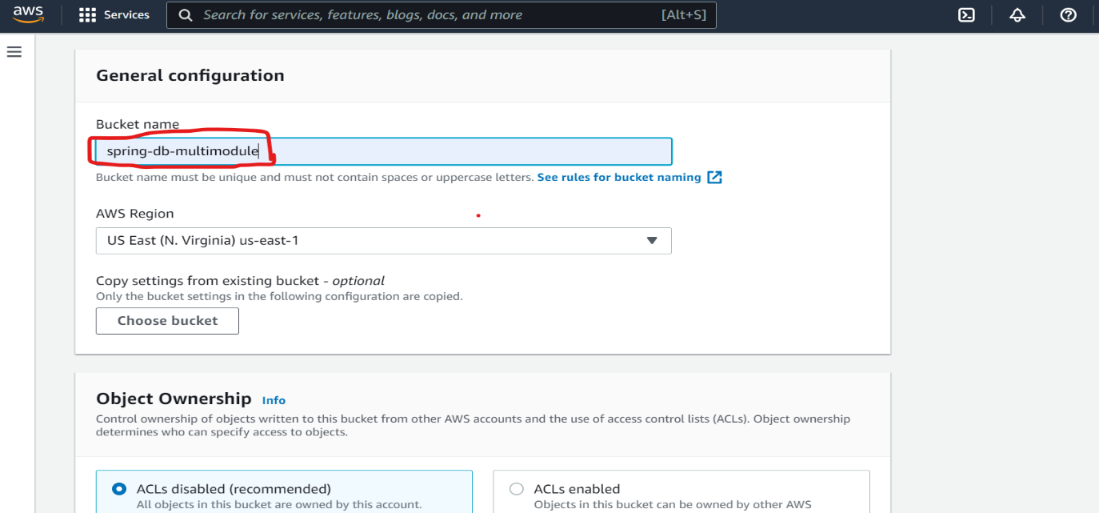

Type in a bucket name for your spring boot application.

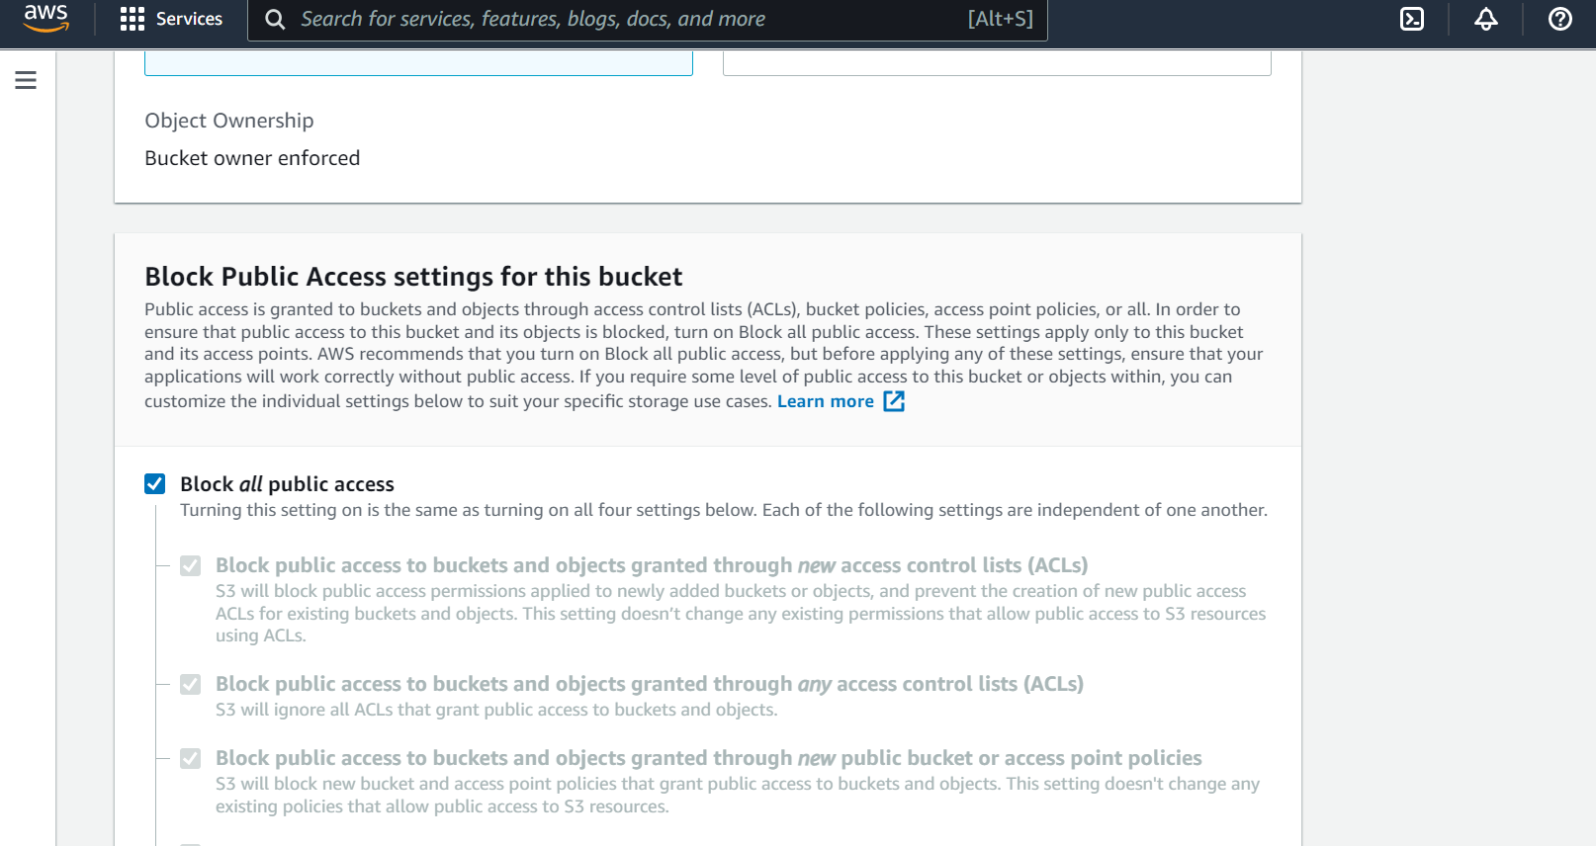

Scroll down to the Bucket Versioning section and select Enable (otherwise it will throw error while deploying)

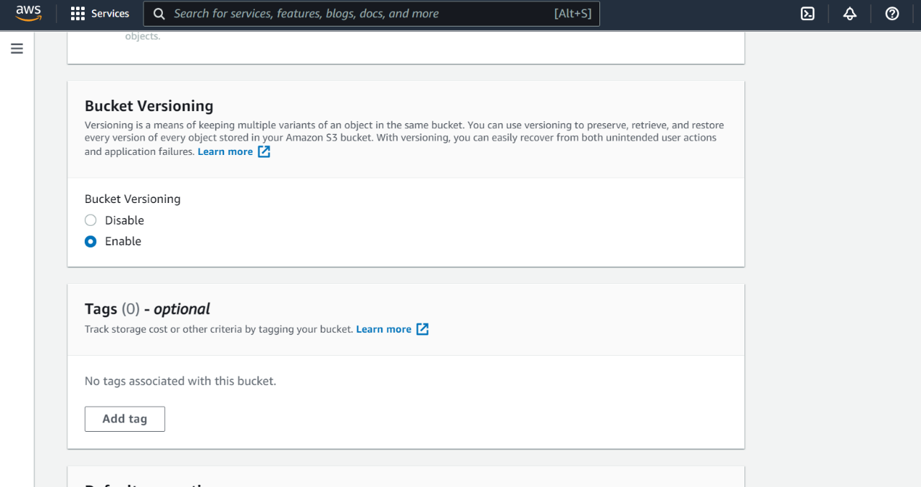

Click on Create Bucket button. You will navigate to the following page.

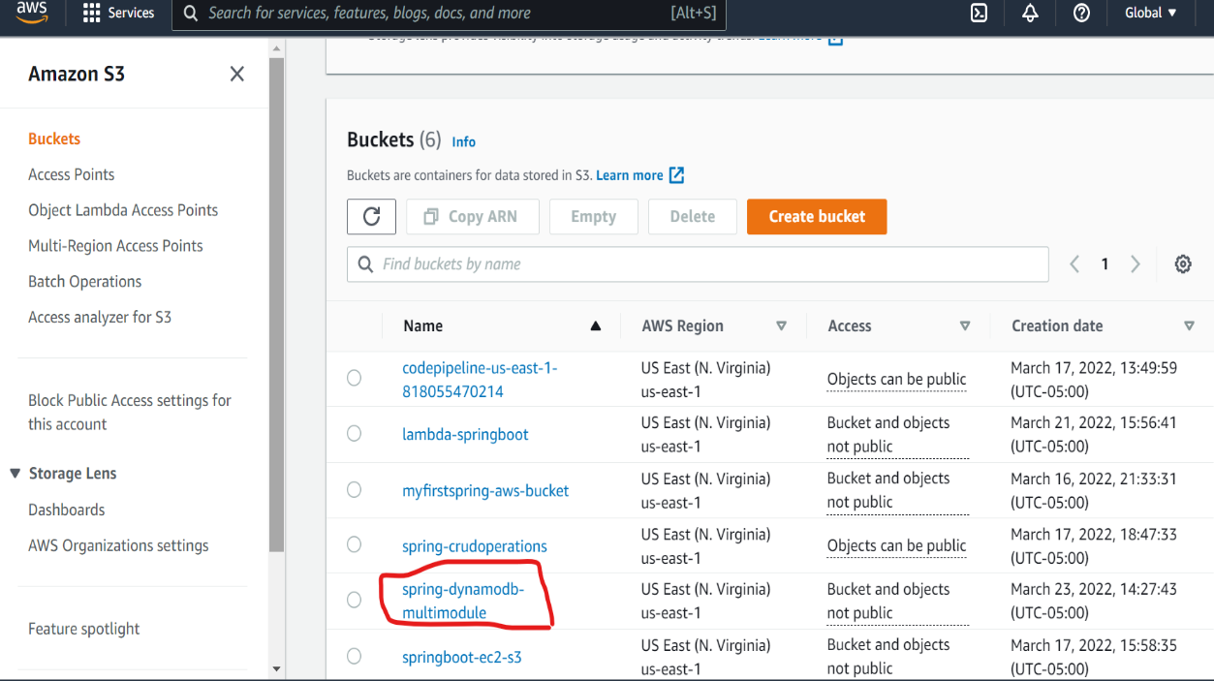

Click on your bucket name. The following page should appear. Upload your zip file to this bucket using the Upload button.

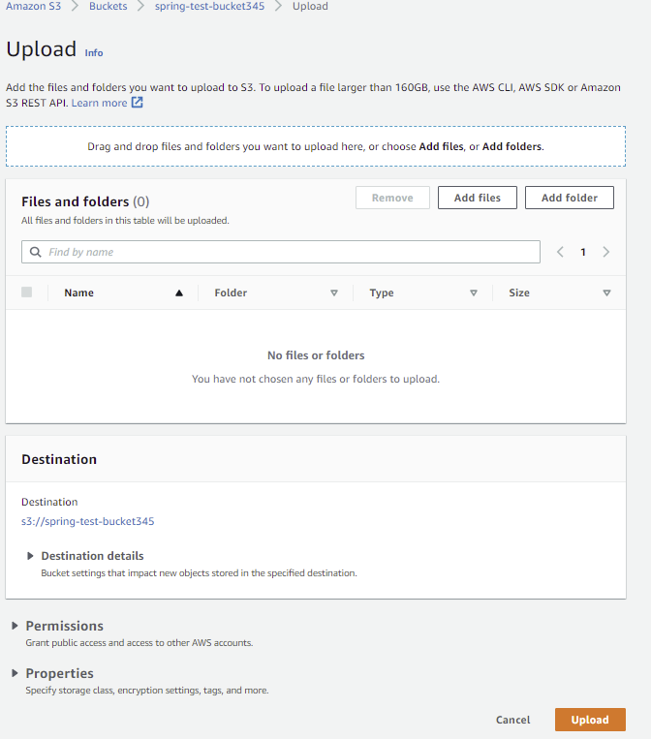

Add the name of the spring boot application zip file to the Files and folder field.

Then Click upload to upload the zip file.

Click the Upload button at the bottom to actually start the upload.

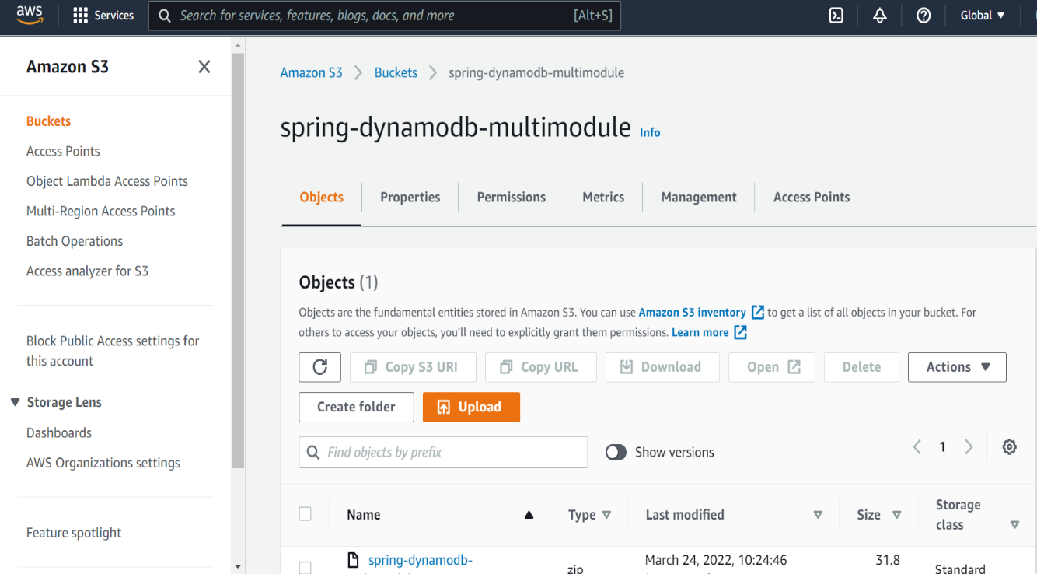

# **5. EC2**

Goto AWS services, type in EC2, and select the EC2 link.

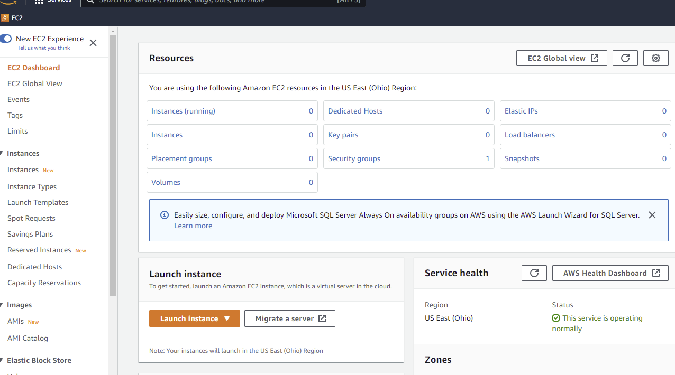

Click the Launch Instance button.

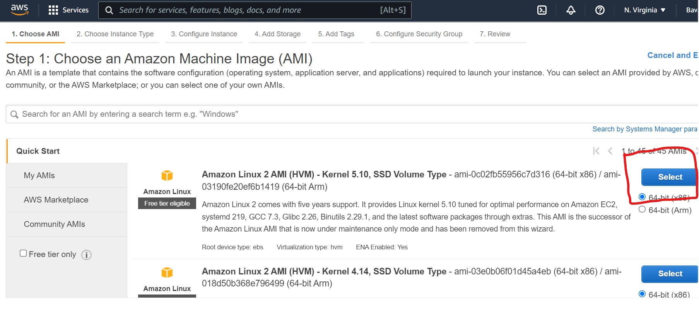

Click on Select for one of the Amazon Linux 2 AMI servers.

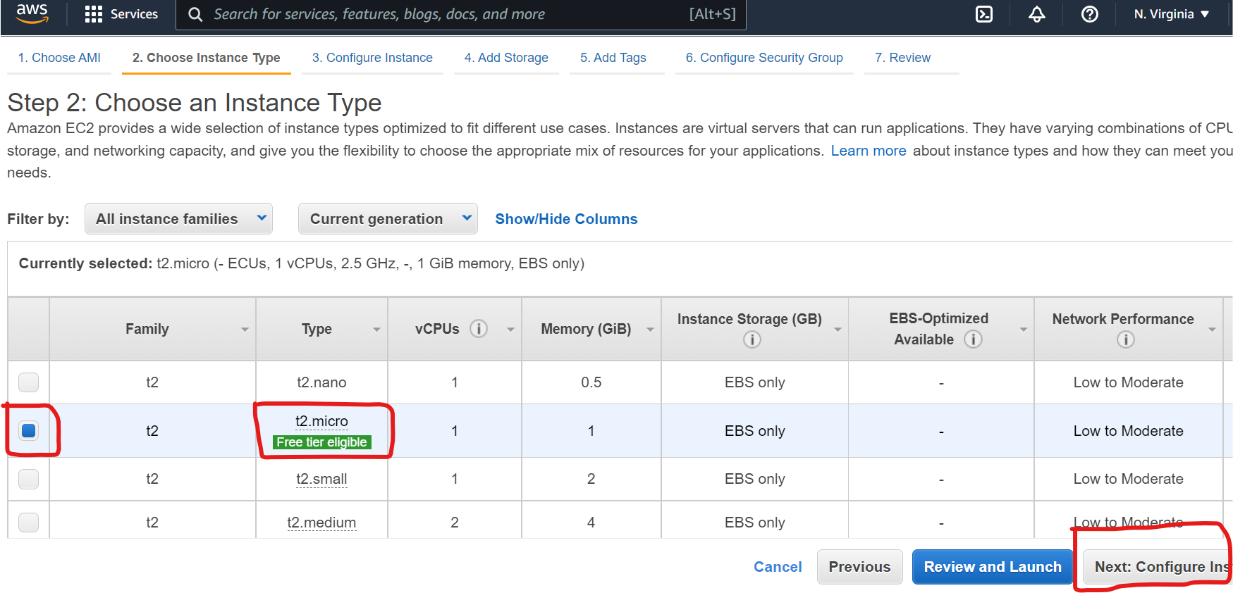

Click on the Next:Configure Instance Details button

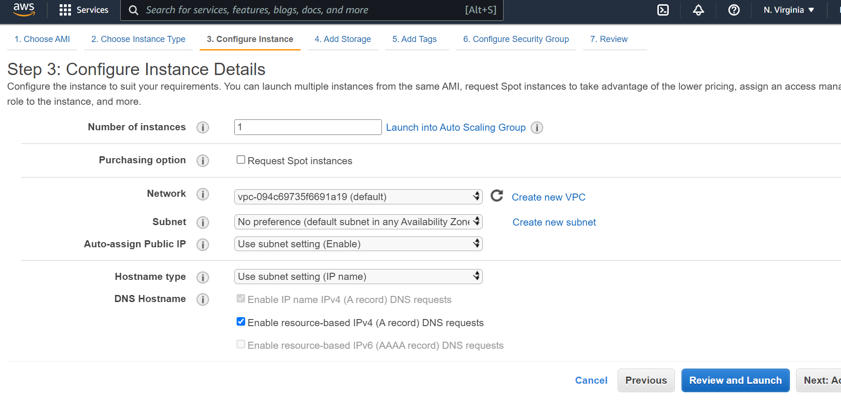

Scroll down and select the IAM role

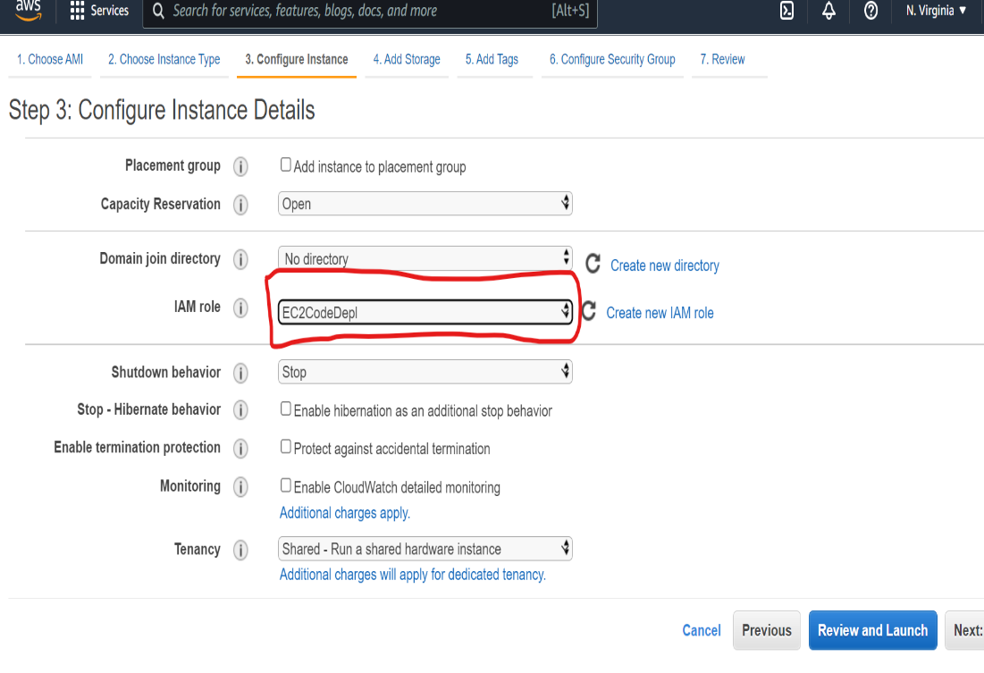

Select the EC2CodeDeploy role from the dropdown field.

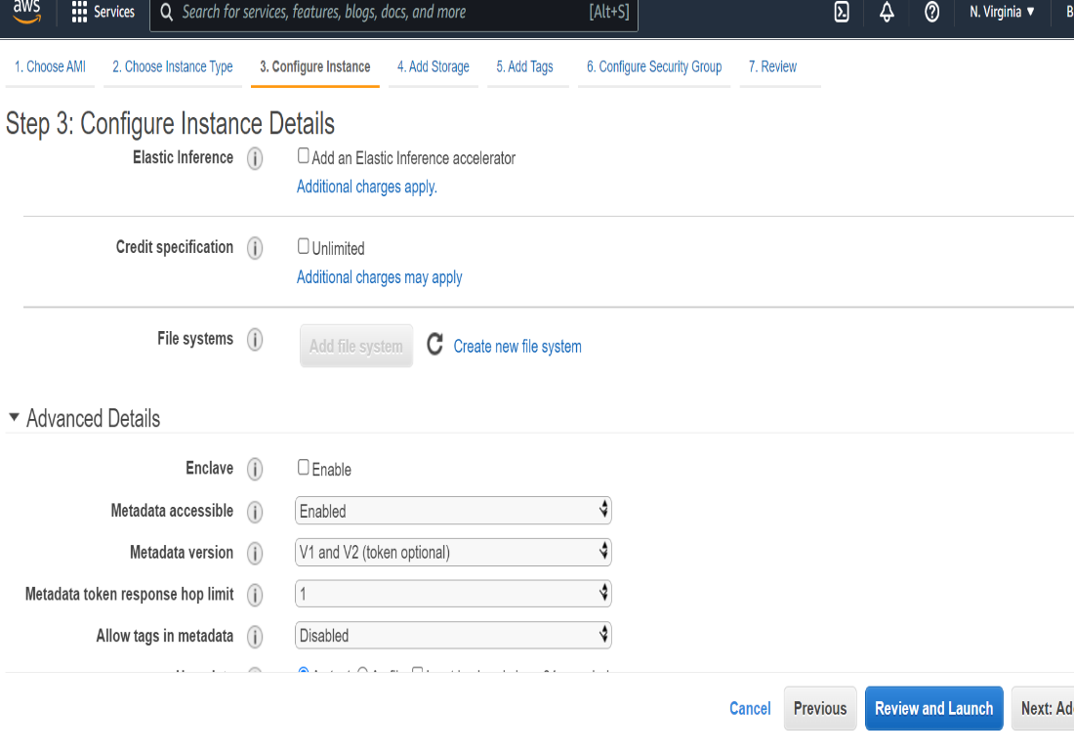

Scroll down to the Advance Details section and add the following script in **the** User Data field**.**

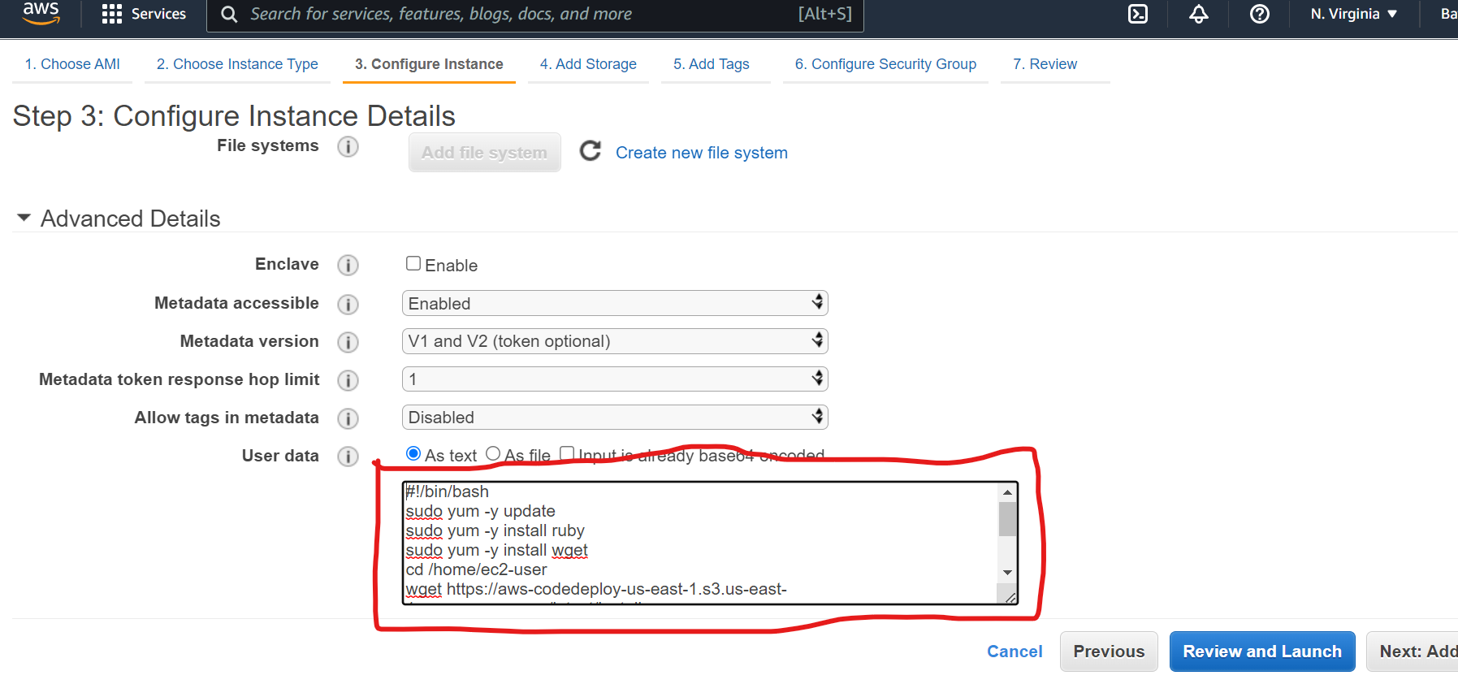

[Script to insert] - not this comment

#!/bin/bash

sudo yum -y update

sudo yum -y install ruby

sudo yum -y install wget

cd /home/ec2-user

wget https://aws-codedeploy-us-east-1.s3.us-east-1.amazonaws.com/latest/install

sudo chmod +x ./install

sudo ./install auto

sudo yum install -y python-pip

sudo pip install awscli

Note: the wget may be from us-east-2 depending on the region for your bucket and EC2 instance.

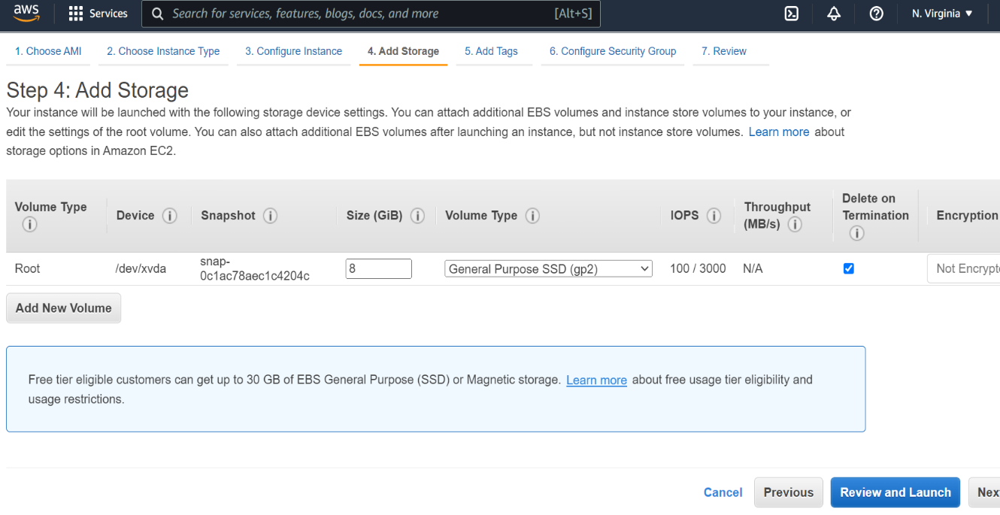

Click on the Next: Add Tags button. (skipping Step 4: Add Storage)

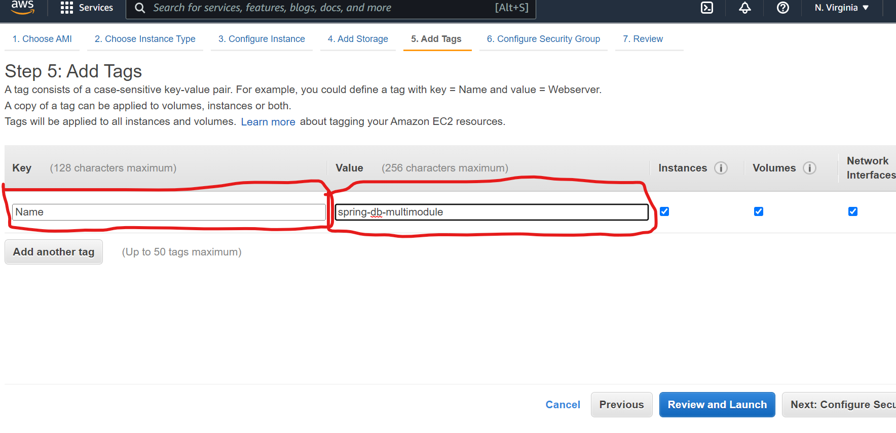

Click on the Add Tag button and type in the key and values displayed above into the fields.

Click on the Next: Configure Security Group button in the lower right-hand corner of the page.

Type in the following Security Group Name displayed on the following page

Add the Security Groups also displayed on the following page.

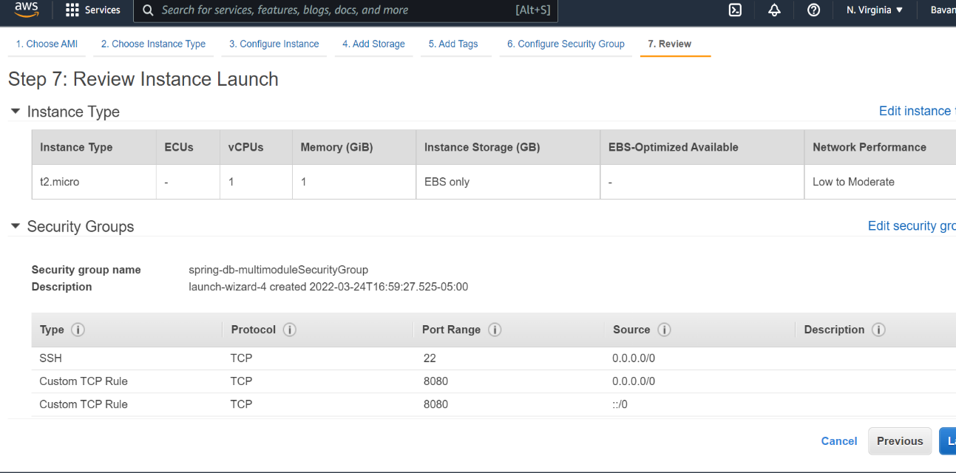

Then Click on Review and Launch button in the lower right-hand corner of the page after the Security Group Name and Security Groups have been filled in. Click on the next Lanch button

Select from the dropdown field, Proceed without a key pair.

If you want to configure or need to change something involving the EC2 instance, click the Instance ID and make your changes. When done with your changes Click on the Launch Instance button.

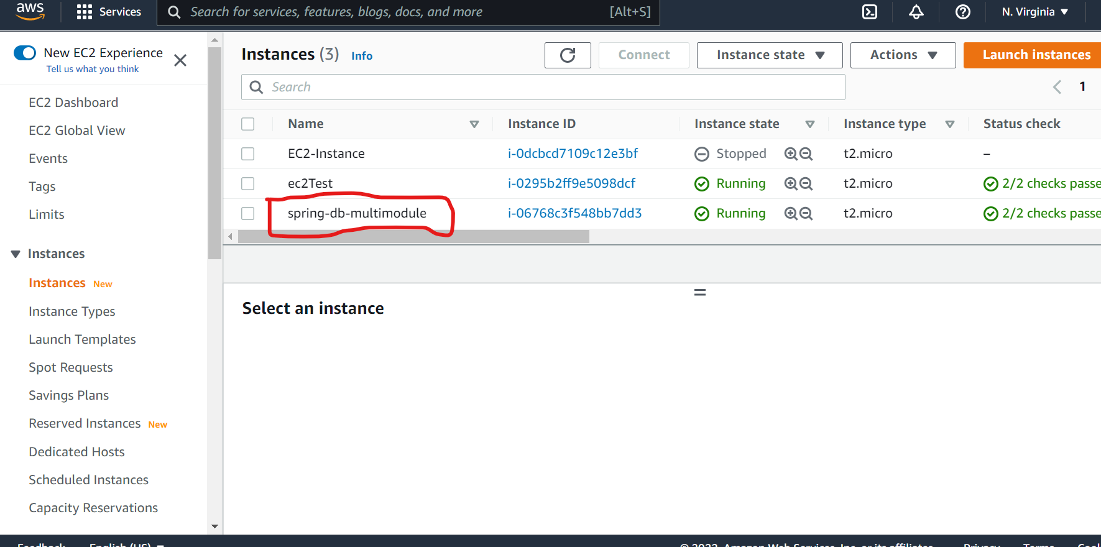

# **6. Code Deploy**

Goto AWS services, type in CodeDeploy, and select the CodeDeploy link.

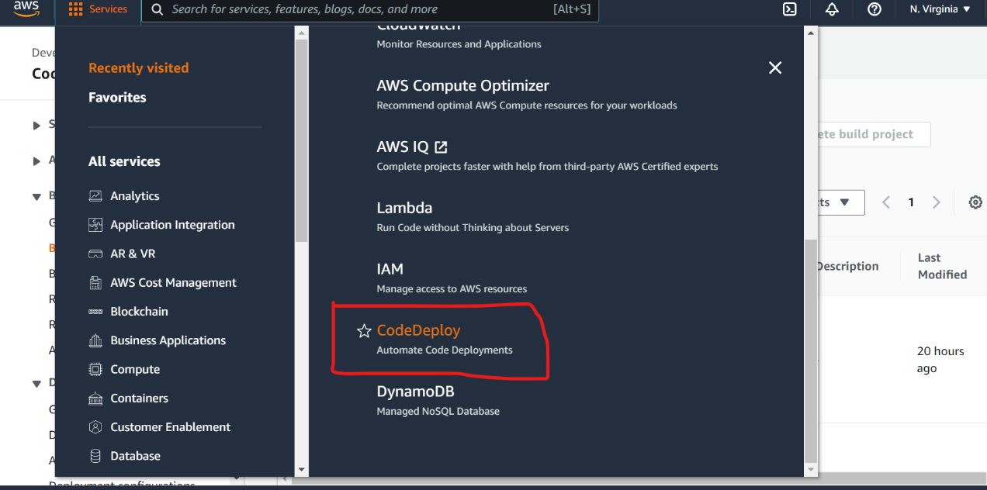

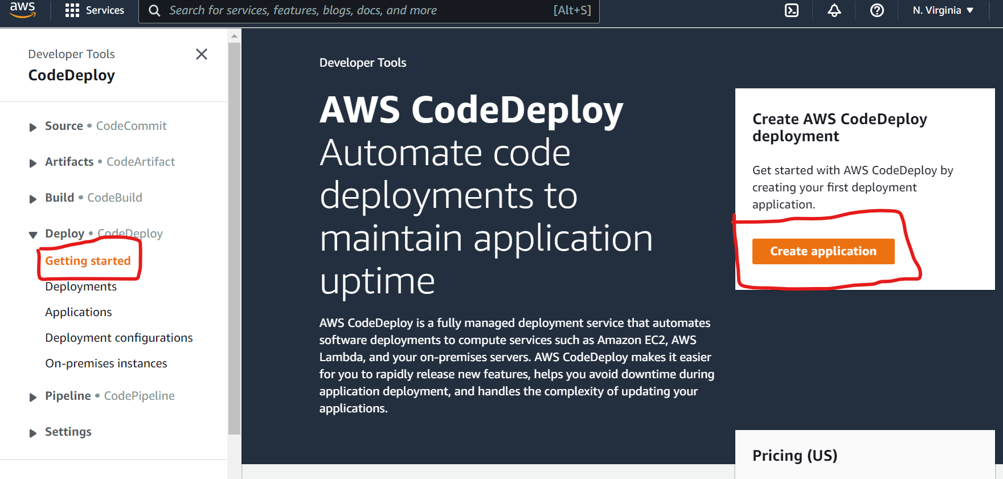

Click on the Getting started button under Deploy.

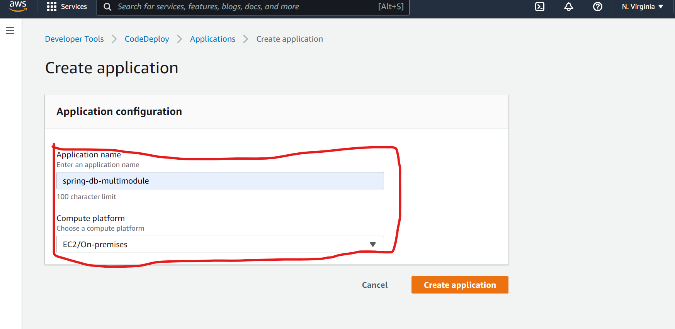

Type in the application name and select the Compute platform fields (see above)

Click on Create application button.

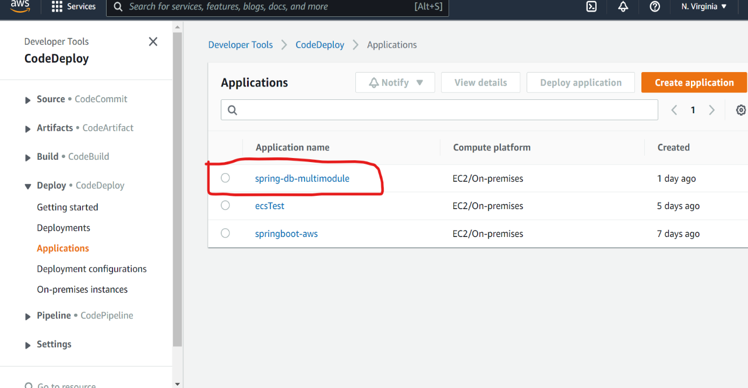

Click on your application created in the previous step.

## **Creating a Code Deployment Group**

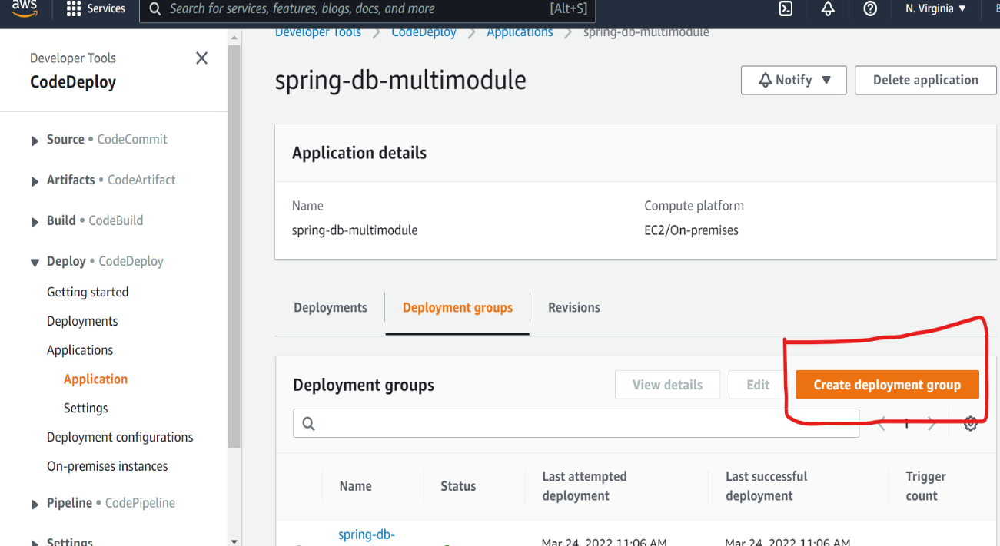

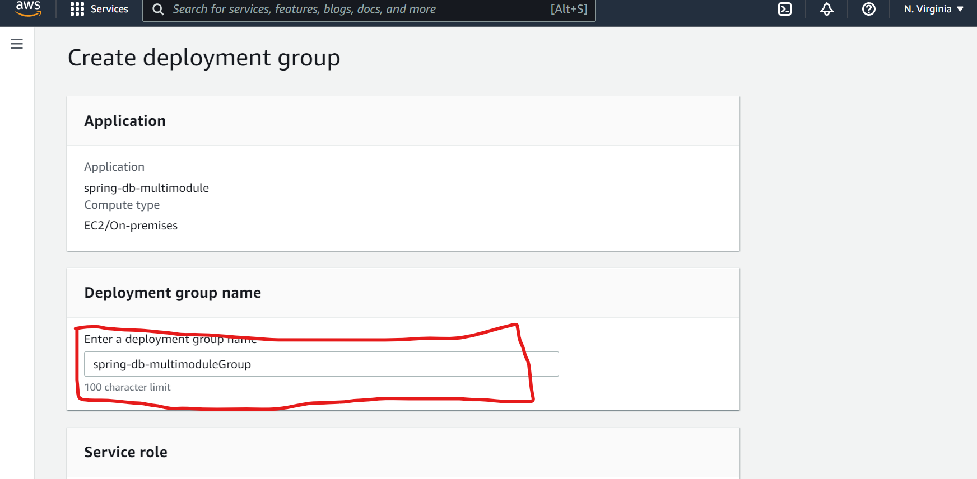

Type in a deployment group name (see above)

Scroll to the Service role drop down and select the service role [CodeDeployRole]

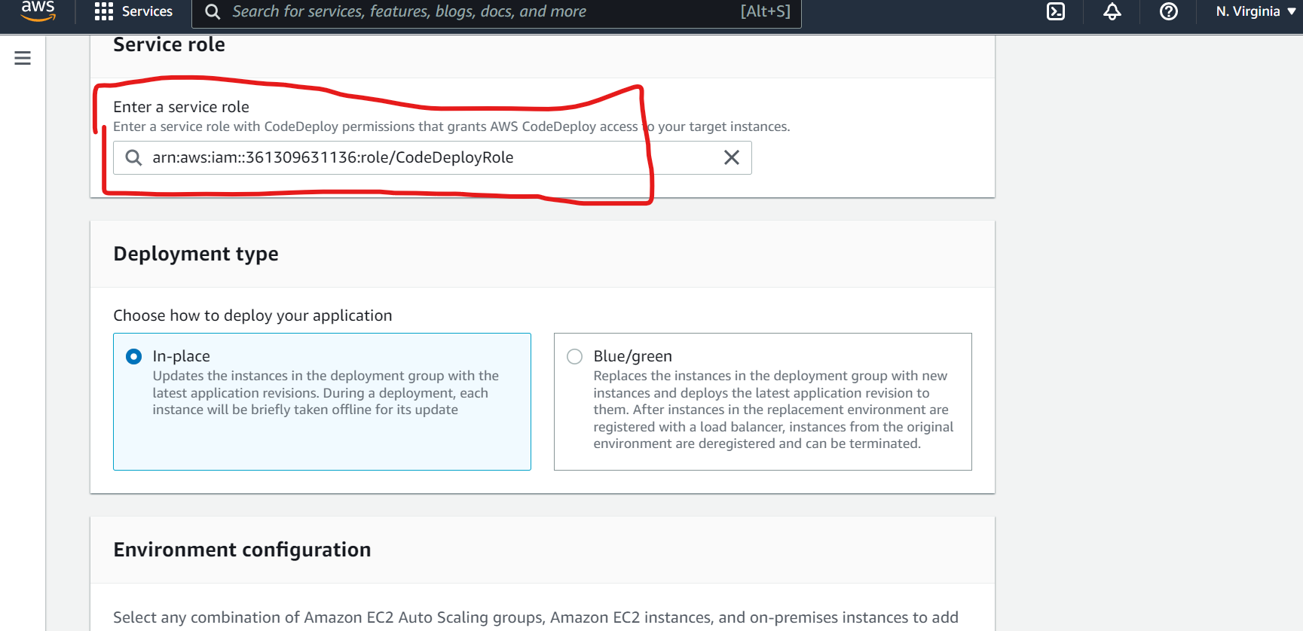

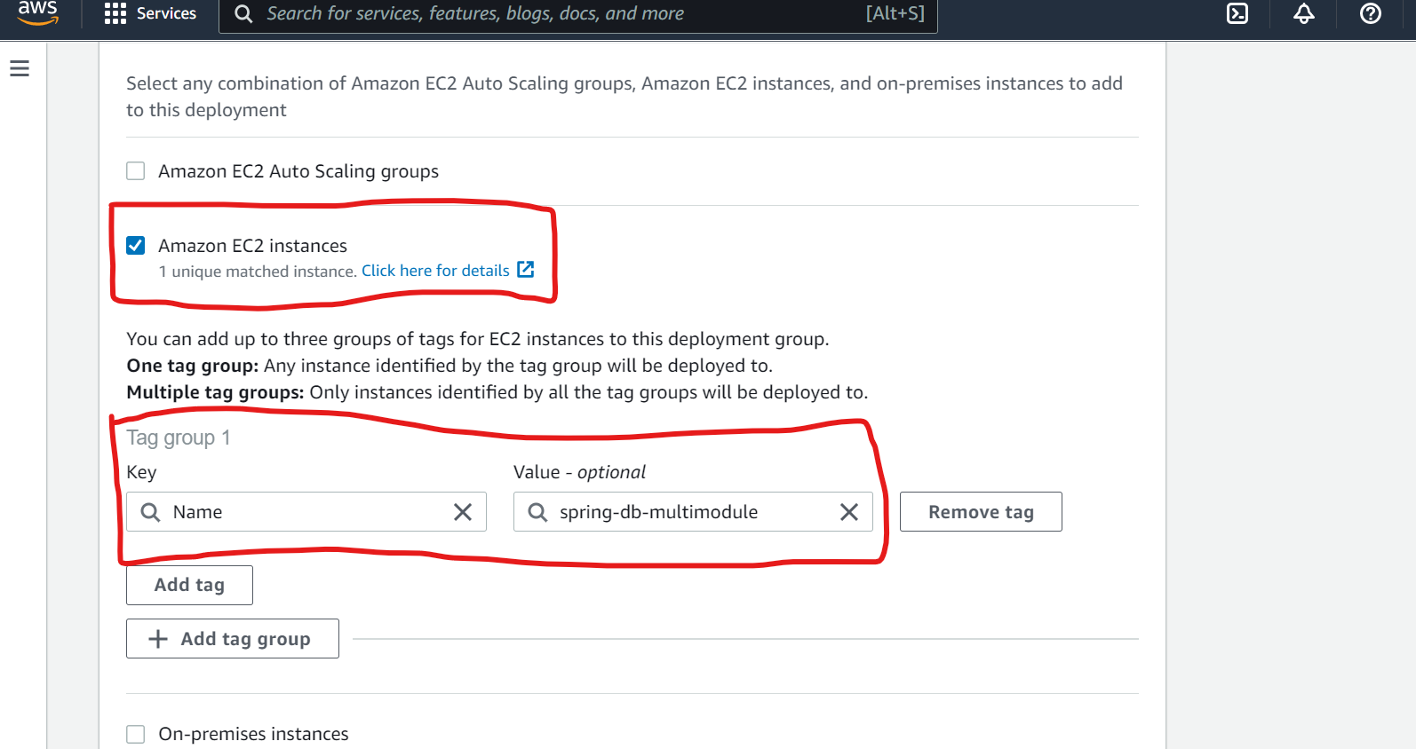

Scroll down the page.

Click the Amazon EC2 instances checkbox.

Add a Key named ‘Name’ and a value from the dropdown field. Ie. Spring-db-multimodule

**Make sure you select the correct EC2 instance for this application**

Scroll down the same page to the Agent configuration with AWS Systems Manager section.

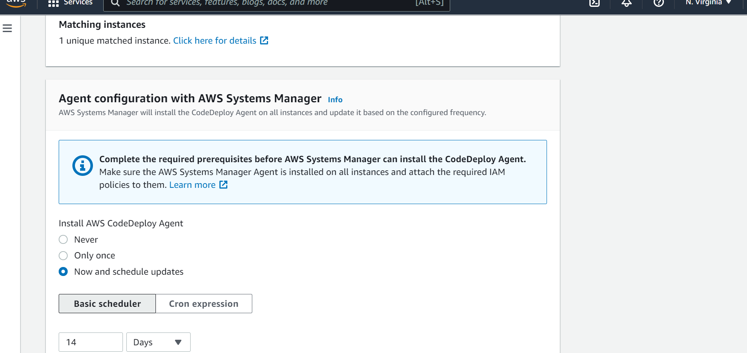

Uncheck the Enable load balancing control.

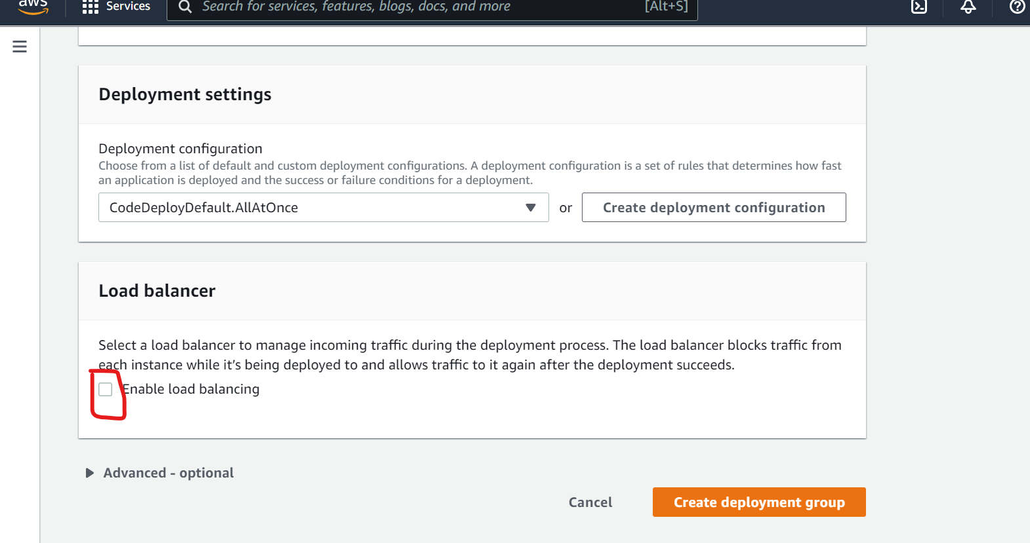

Click on the Create Deployment group button.

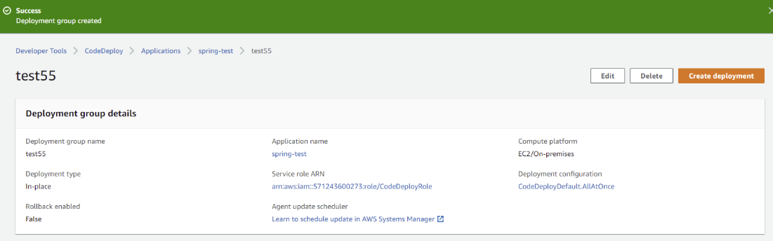

Your Deployment Group should be displayed.

# **7. Creating a Code Pipeline**

Goto AWS Services, type in CodePipeline, and select the CodePipeline link.

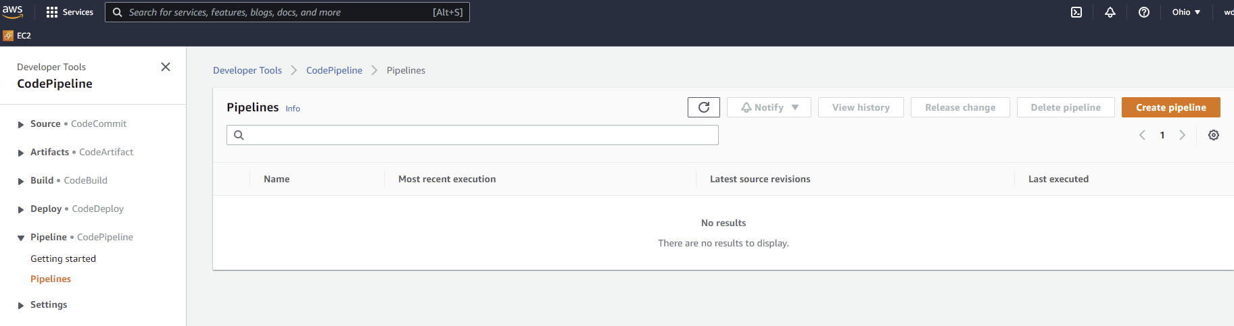

Select the Getting started link under Pipeline

Click the Create pipeline button.

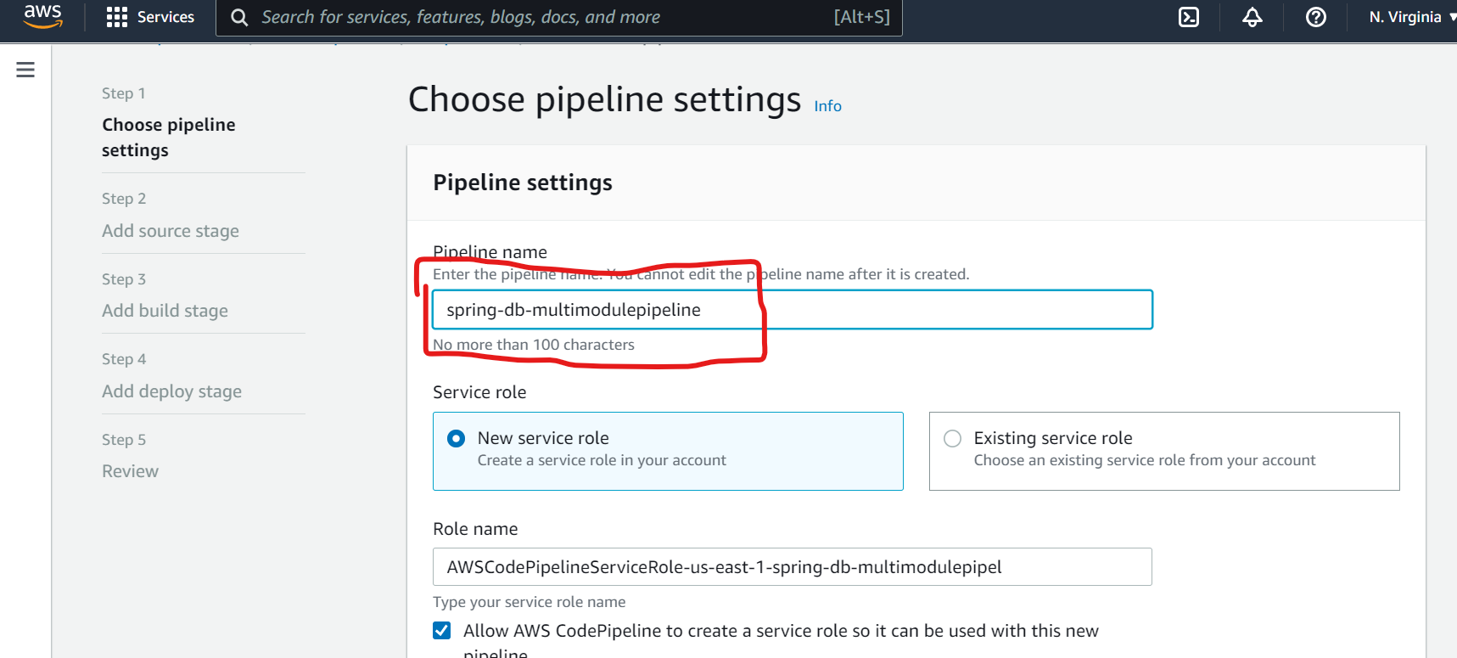

Type in a name for your pipeline. See above. In the Role Name, make sure the region is the one you are using.

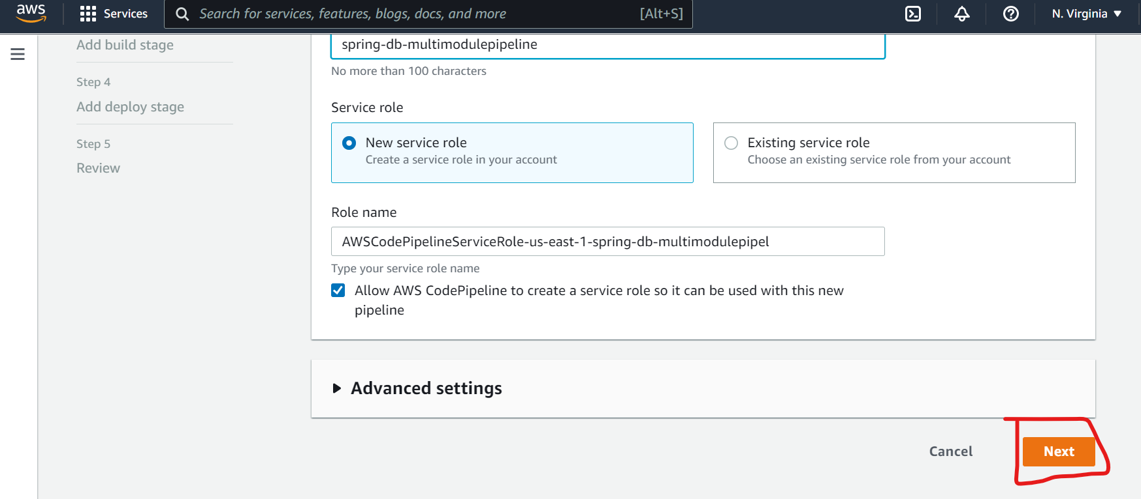

Click the Next button.

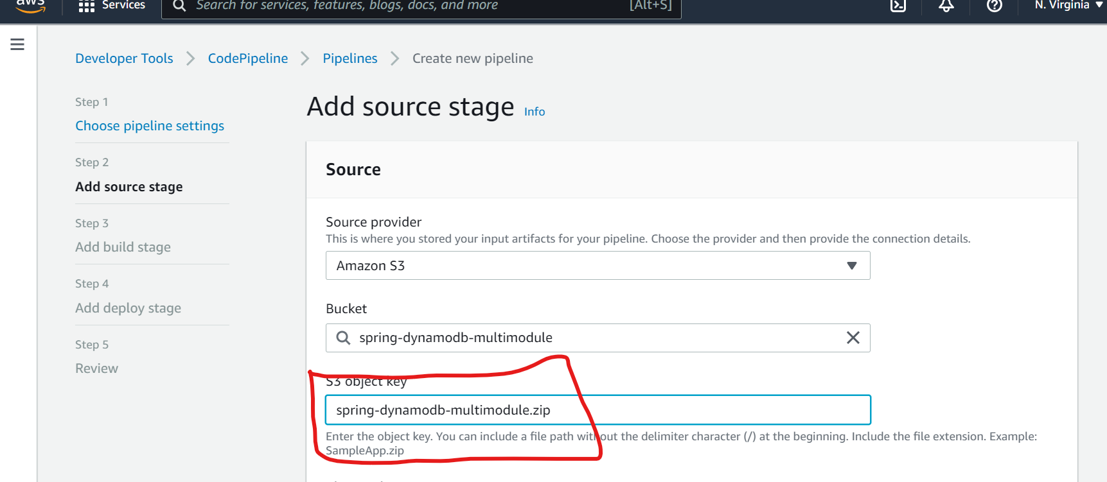

Select Amazon S3 as the source provider.

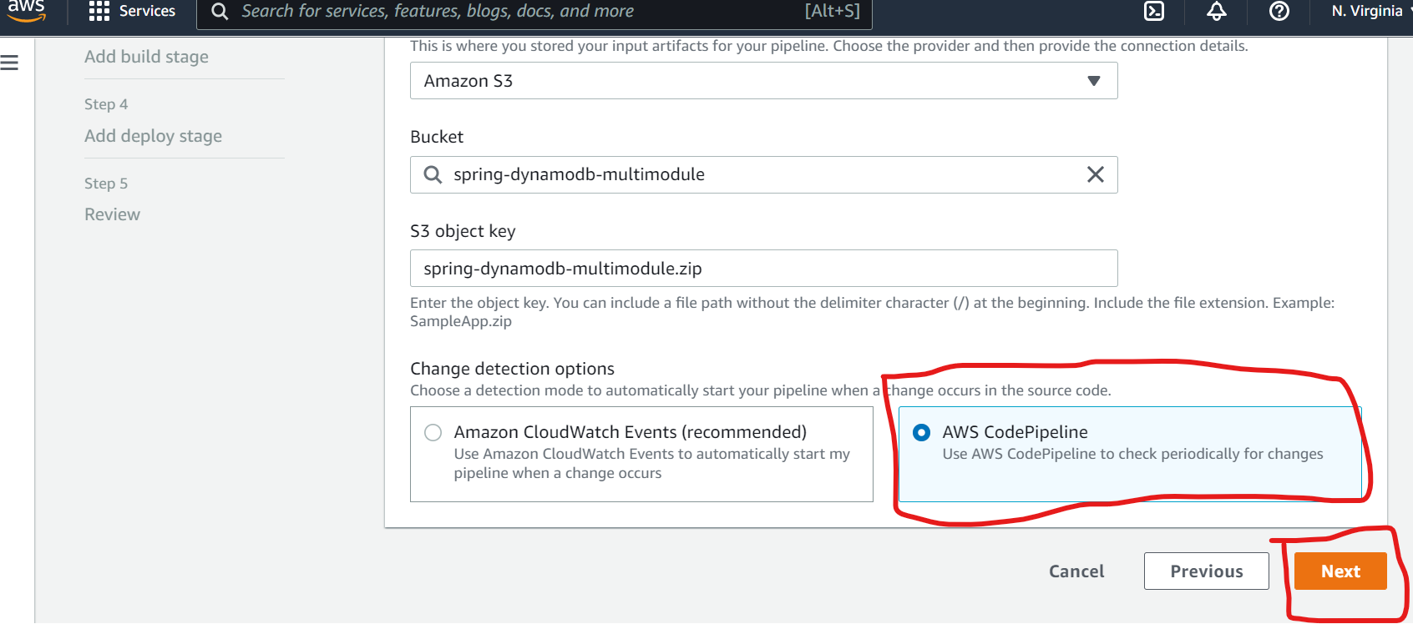

**Make sure the bucket and S3 object name (application zip file names) are correct.

You can duplicate the tab and navigate to the S3 services to check the names.

Select/enter your bucket from the dropdown field. (See above)

Select/enter your S3 object from the dropdown field. (See above)

Select the AWS CodePipeline radio button.

Click the Next button.

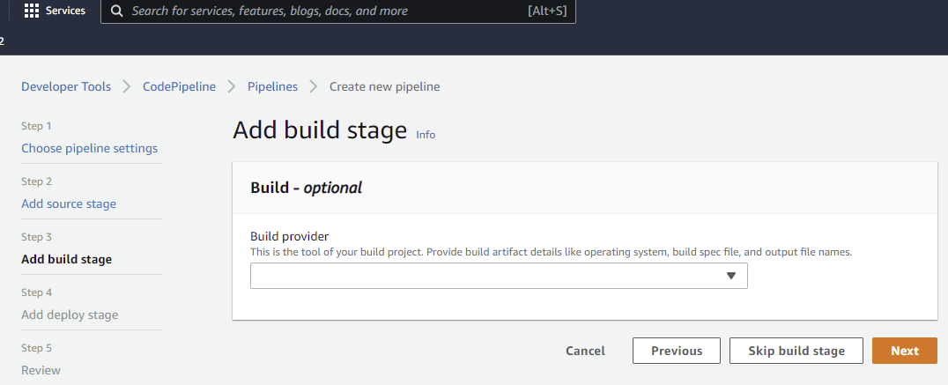

At the code build page, click on the Skip build stage button. No build is required.

Click the Skip button if needed.

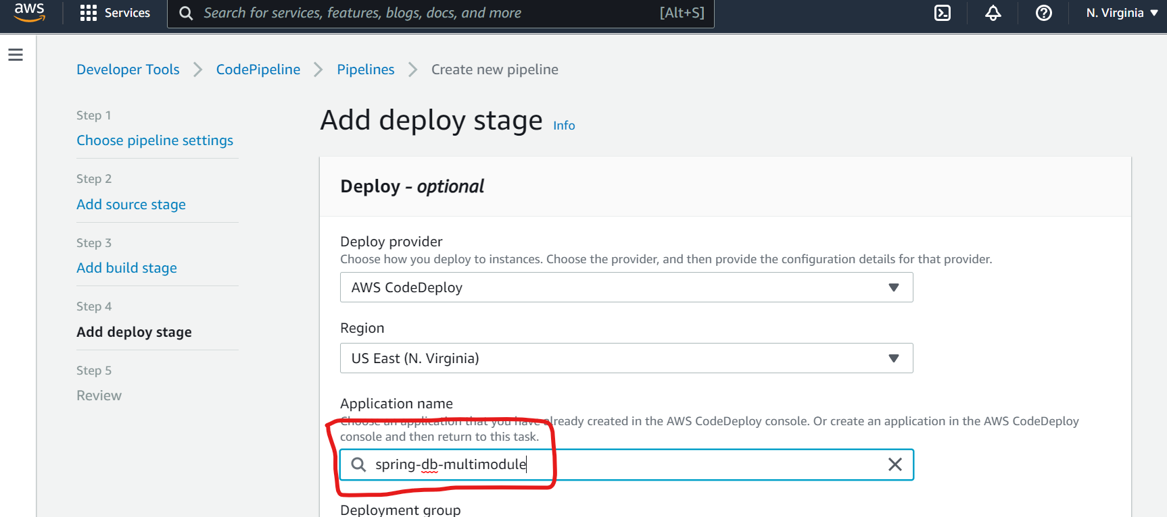

The Deploy provider should be AWS CodeDeploy.

Type/select in the name of the application name in the Application name field. It should be available in the dropdown field.

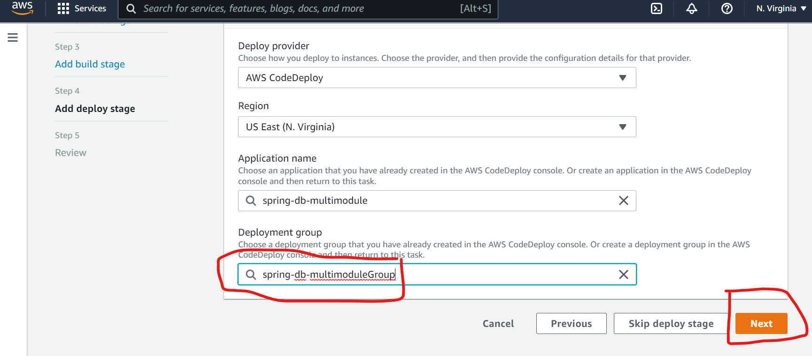

Type/select the deployment group. See above. It should be available in the dropdown field.

Click the Next button to see a Review of the pipeline settings.

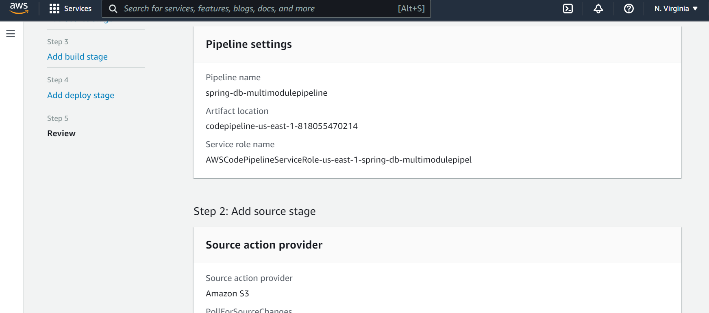

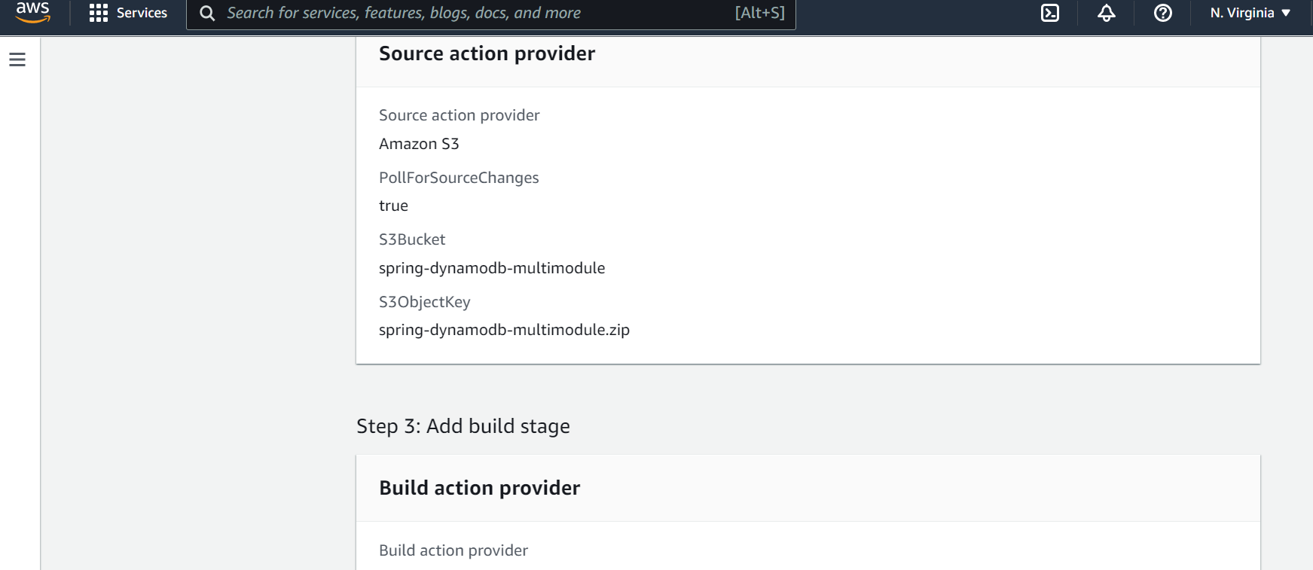

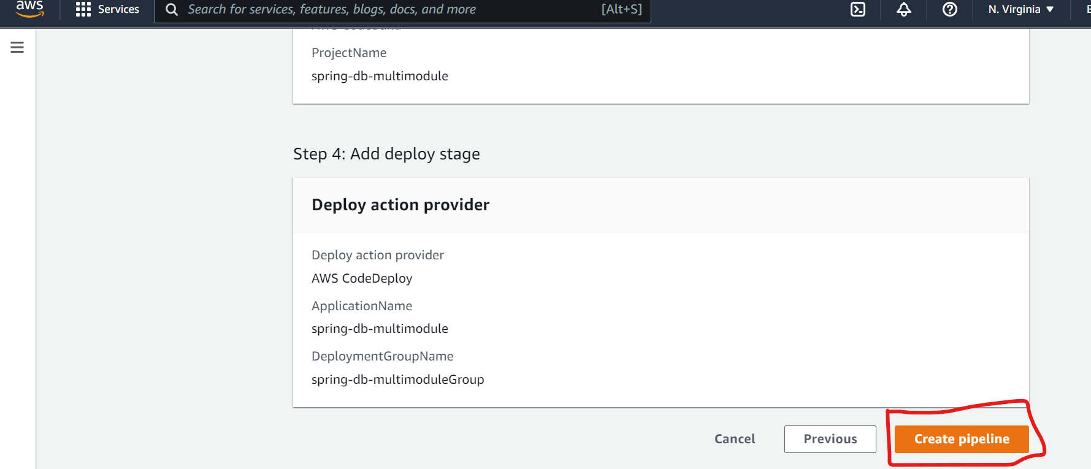

Click on the Create pipeline button if the pipeline settings are correct.

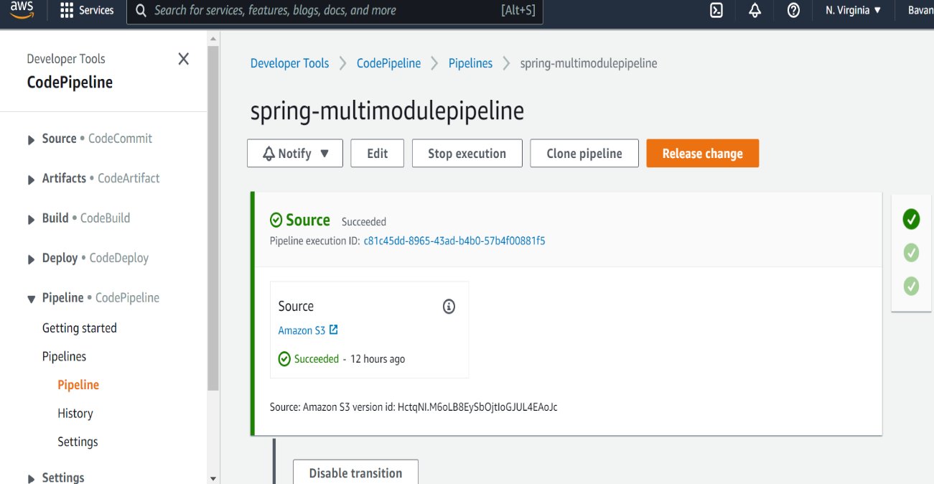

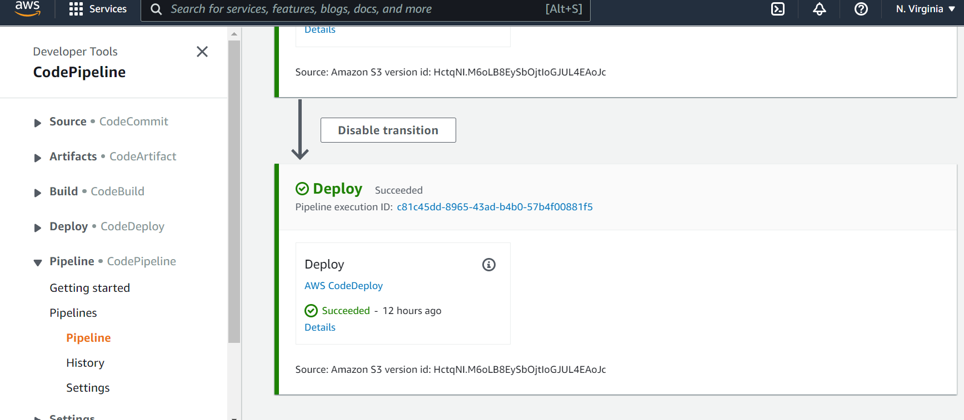

Goto AWS services, type EC2 and select the EC2 link.

Click on the Instance link in the EC2 Dashboard.

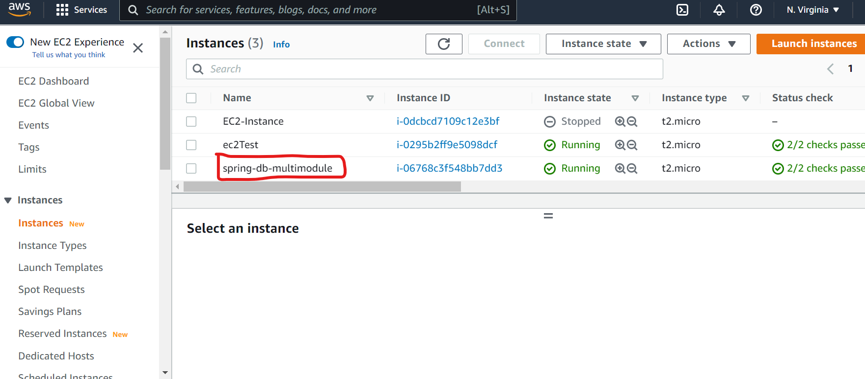

Click on your EC2 instance Id.

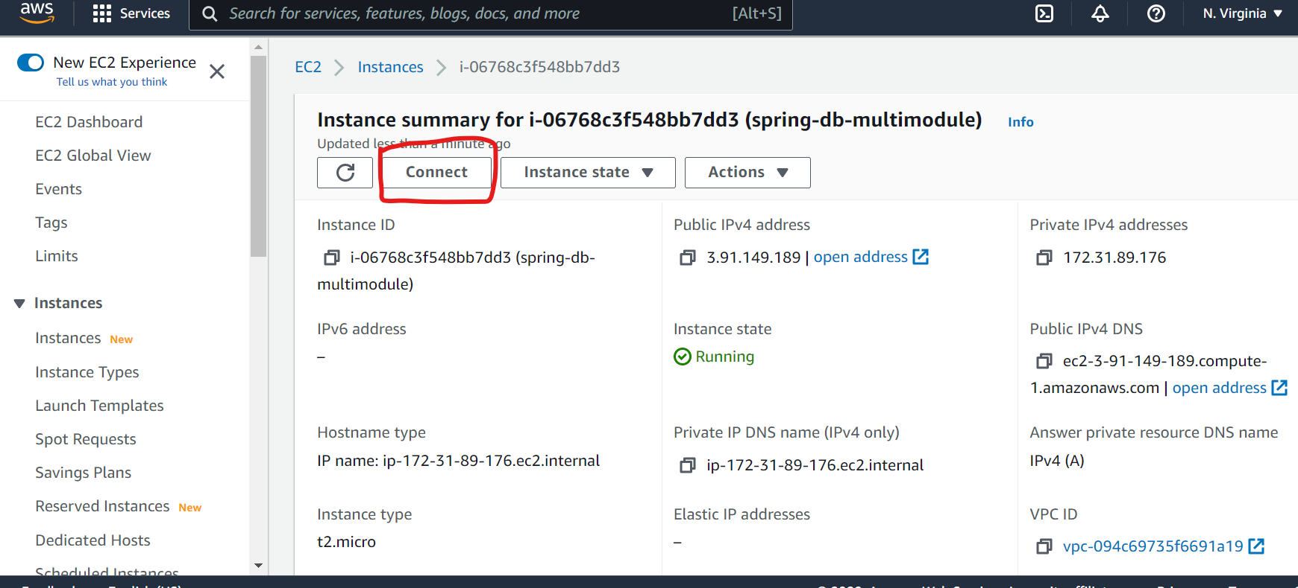

Click on Connect button (for the EC2 server)

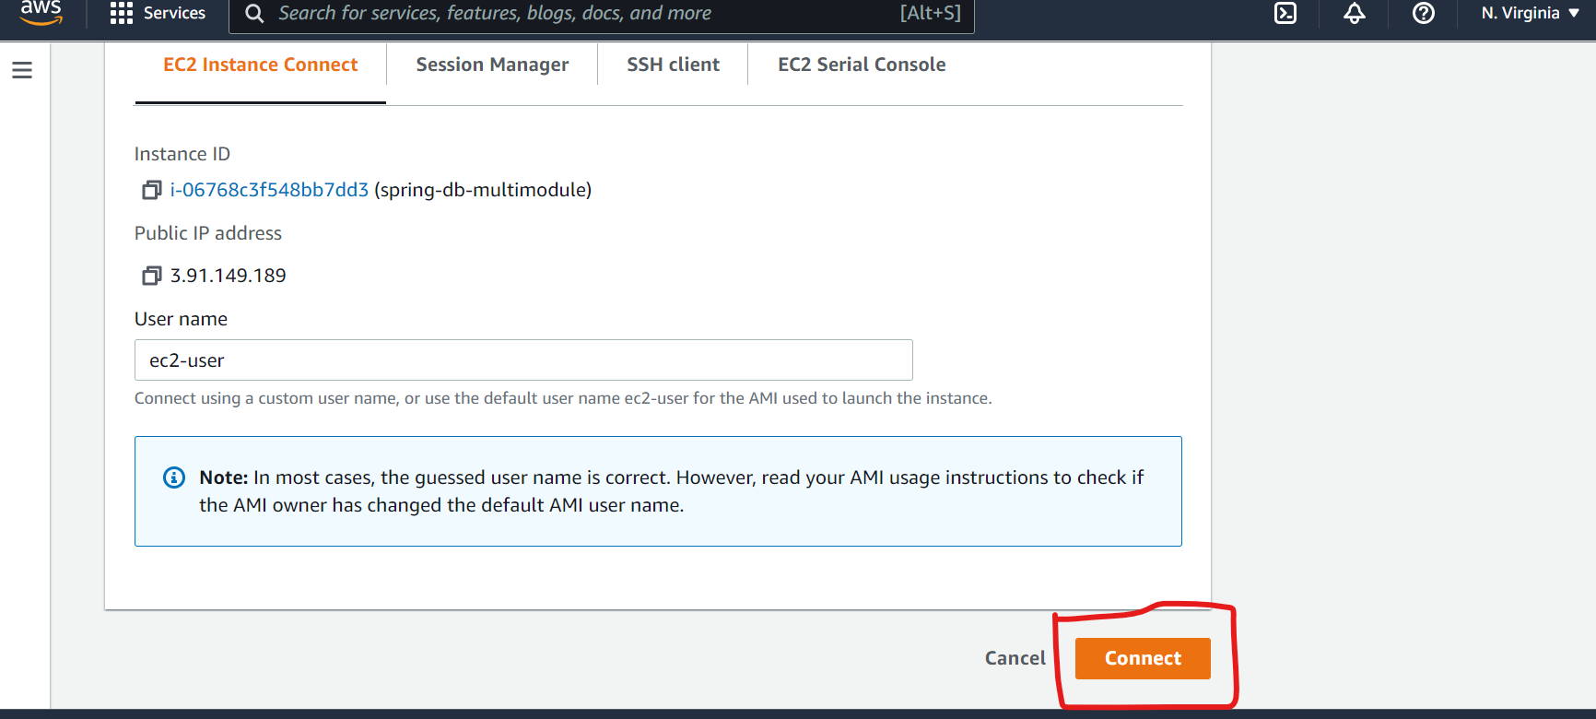

Click on Connect button.

# **8. Installing java 17 sdk and checking the setup**

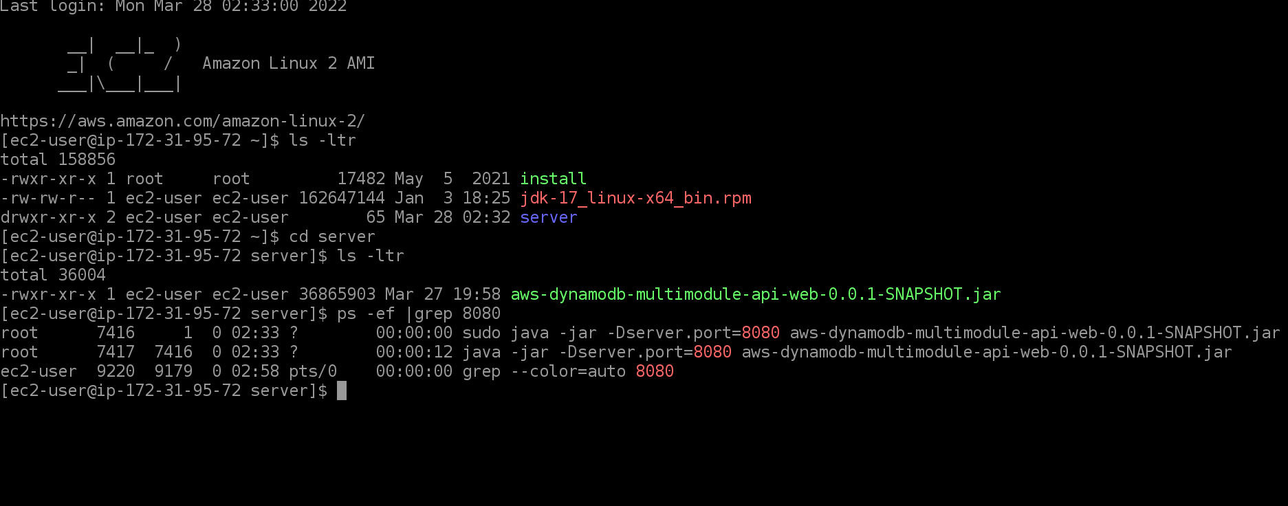

Now installed the java 17jdk on the EC2 instance by running the following two commands at the command line on the EC2 instance.

Check the java version with:

java –version

If it is already installed skip the following two commands.

wget <https://download.oracle.com/java/17/latest/jdk-17_linux-x64_bin.rpm>

sudo rpm -Uvh jdk-17_linux-x64_bin.rpm

ls –ltr

cd server

ls –lrt

ps –ef | grep 8080

There should be a process running with 8080 in the process list.

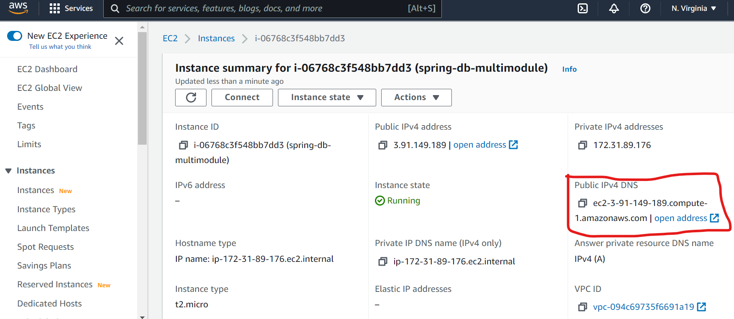

Copy the public ip from the page for you EC2instance (It can be found by Selecting Instances from the EC2 Dashboard and then click on the Instance Id for your instance that you created.

**Check that the endpoints work by using the link below either in browser or Postman**

**\*\*Your EC2 instance will be different and make sure you copy it from the EC2 instance Id page**

**ie: ec2-2-3-91-149-188-compute-1.amazonaws.com:8080/all-orders**

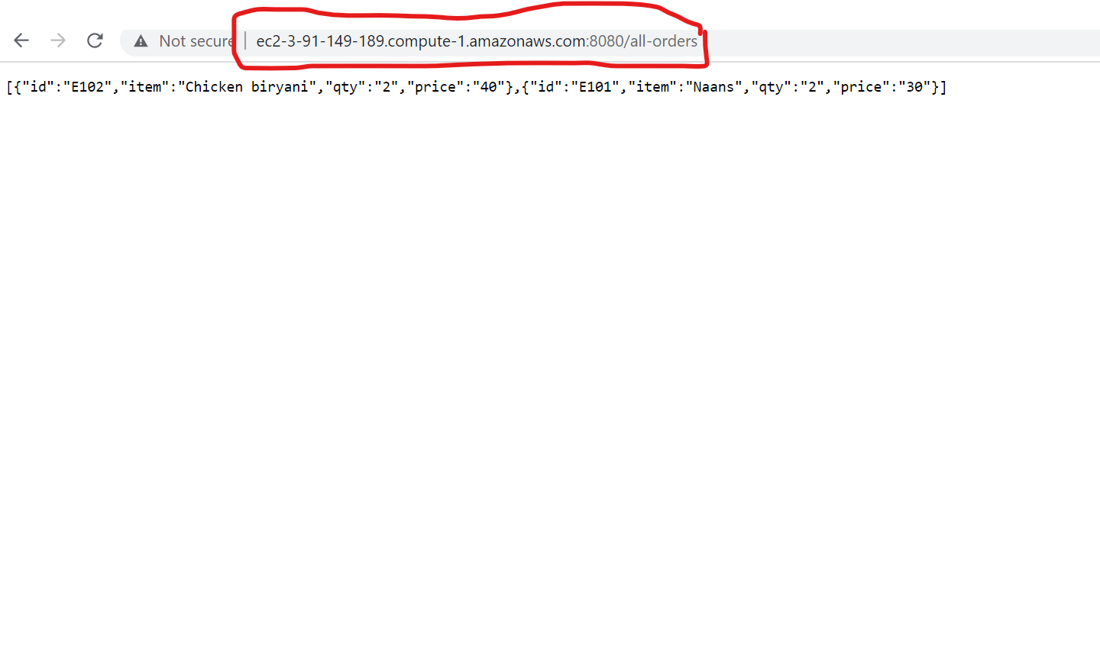

# **APPENDIX**

# **A. Configure IAM Roles**

Go to aws->services->select IAM. Suppose you didn’t create roles related to Ec2CodeDepl and CodeDeployRole . Then follow the steps below- to configure 2 Roles.

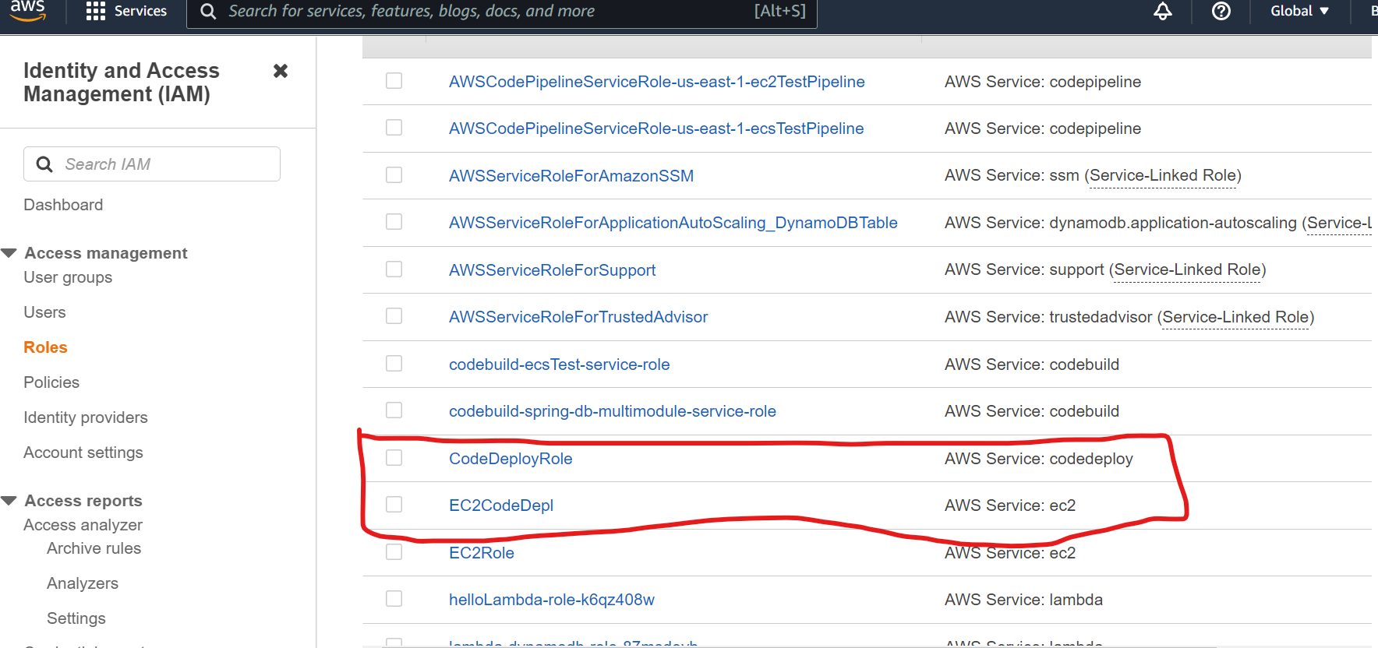

If the above two roles are not configured go to the steps below otherwise skip roles.

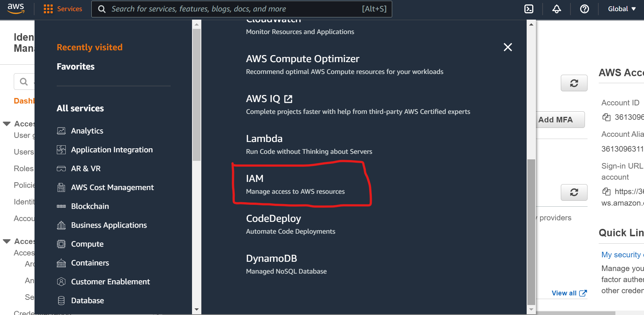

Then Click on Roles from Navigation bar at left side. Then click on Create Role

# **B. EC2Role**

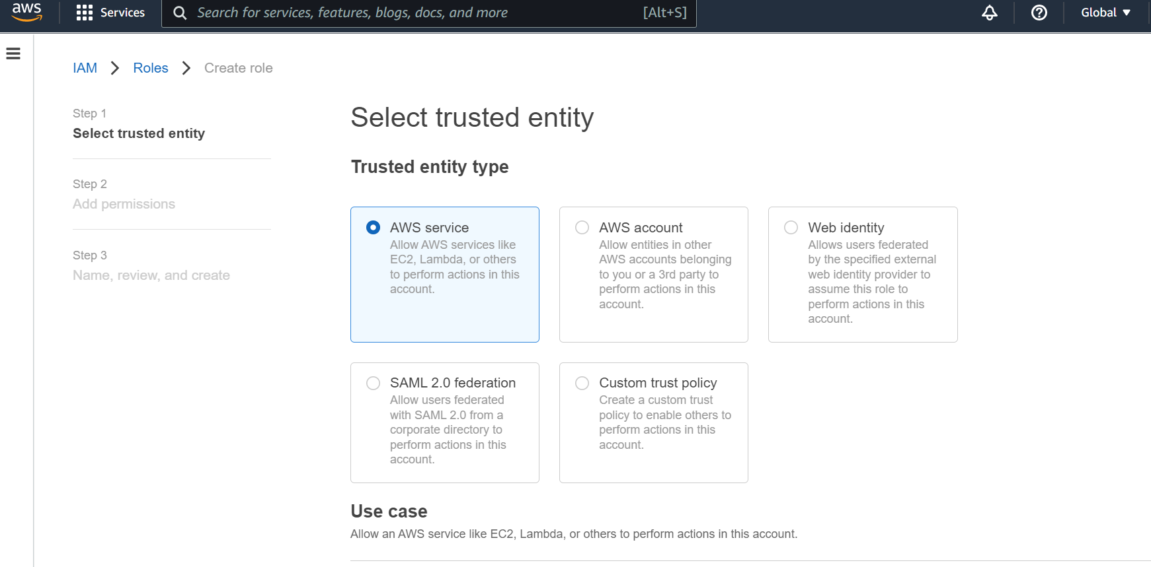

Scroll Down

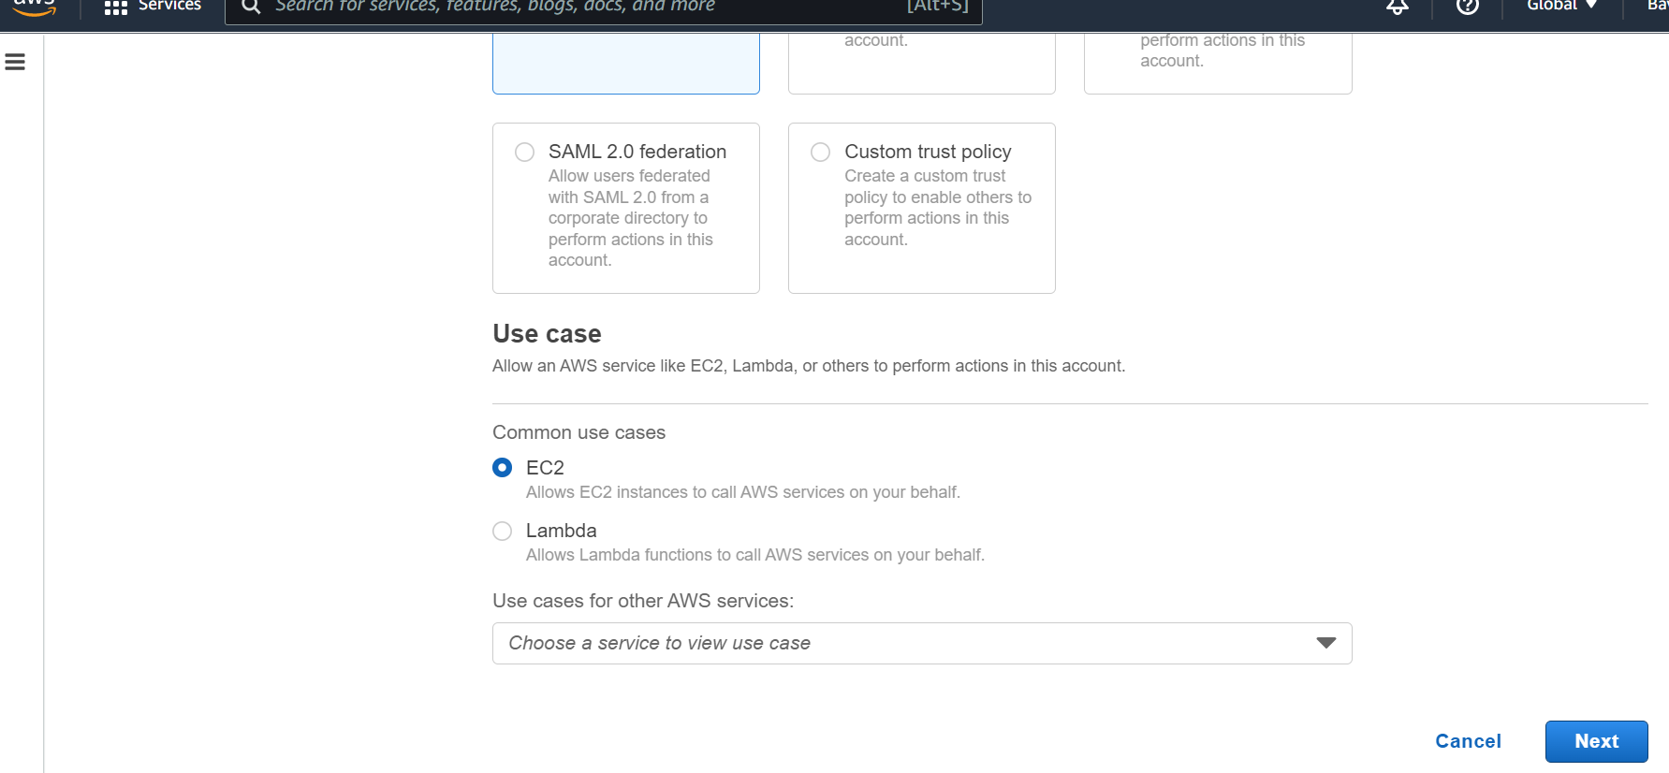

Click On Next. Select [**AmazonEC2RoleforAWSCodeDeploy**](https://us-east-1.console.aws.amazon.com/iam/home#/policies/arn:aws:iam::aws:policy/service-role/AmazonEC2RoleforAWSCodeDeploy) **, and click on next give role name and add tags and click on create role. Then if you click on created role this page will appear**

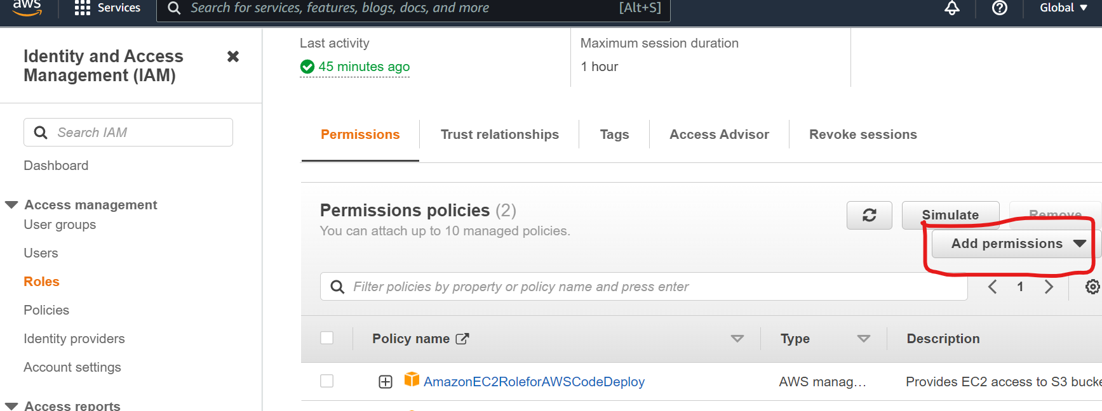

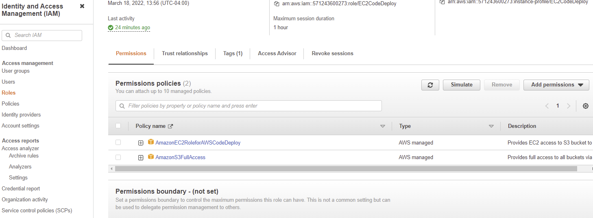

Click on add permissions and select attach the IAM policy. Select AmazonS3FullAccess from the list.

Click on the Roles link in the left navigation panel. Click on Create Role.

# **C. CodeDeployRole**

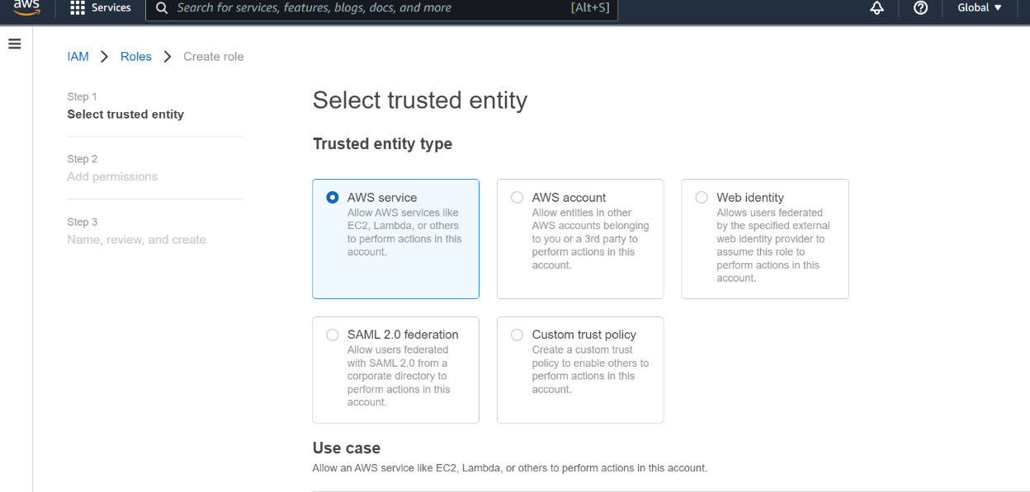

Scroll Down

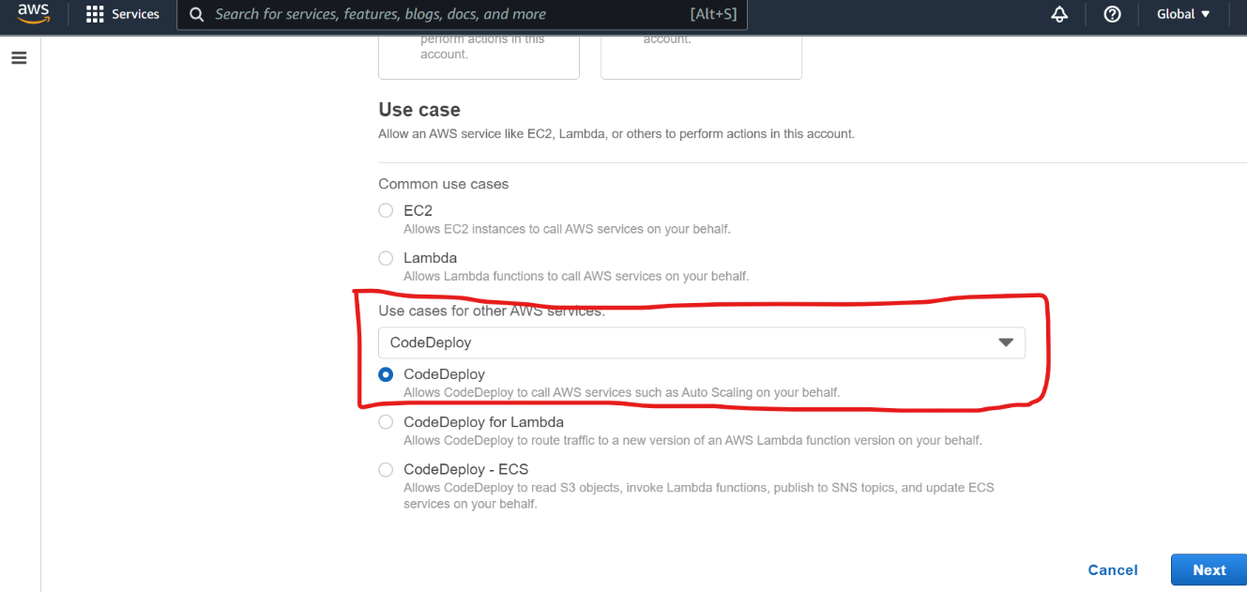

Click on the Next button.

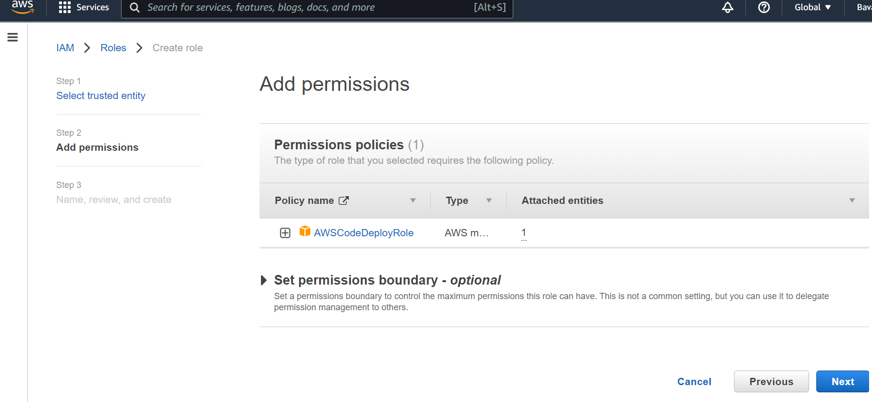Click on the Next button.

That’s it for Roles.

# **D. Required Files and scripts**

A. appspec.yml

version: 0.0  
 os: linux  
 files:  
 - source: / aws-dynamodb-multimodule-api-web/build/libs/aws-dynamodb- multimodule-api-web-0.0.1-SNAPSHOT.jar   
 destination: /home/ec2-user/server  
 permissions:  
 - object: /  
 pattern: "**"  
 owner: ec2-user  
 group: ec2-user  
 hooks:  
 BeforeInstall:  
 - location: scripts/server_clear.sh  
 timeout: 300  
 runas: ec2-user  
 AfterInstall:  
 - location: scripts/fix_previleges.sh  
 timeout: 300  
 runas: ec2-user  
 ApplicationStart:  
 - location: scripts/server_start.sh  
 timeout: 300  
 runas: ec2-user  
 ApplicationStop:  
 - location: scripts/server_stop.sh  
 timeout: 300  
 runas: ec2-user

Files in scripts folder:

**Make sure the folder and filename are lowercase.

B. scripts/server_start.sh

**#!/usr/bin/env bash**  
**cd** /home/ec2-user/server  
sudo java -jar -Dserver.port=8080 *.jar > /dev/null 2> /dev/null < /dev/null &

C. scripts/server_stop.sh

**#!/usr/bin/env bash**  
**sudo** pkill -f 'java -jar'

D. scripts/server_clear.sh

#!/usr/bin/env bash

FILE=/home/ec2-user/server

if [ -d "$FILE"]; then

sudo chmod 777 /home/ec2-user/server

sudo chmod 777 /home/ec2-user/server/logs

sudo rm -rf /home/ec2-user/server

fi

E.scripts/fix_previleges.sh

**#!/usr/bin/env bash**  
**chmod** +x /home/ec2-user/server/*.jar

# **E. Modifying Application code and re-deploy, re-pipeline**

If you need to change something in the spring boot application, make the application changes and then following the next steps:

Make changes needed within your spring boot project.

Delete your previously created zip file and create another one from the root directory of the spring boot project.

Go to AWS services, type in S3, and select the S3 link This will go to AWS Amazon S3 where you can upload your application zip file.



Click on the link for your bucket.

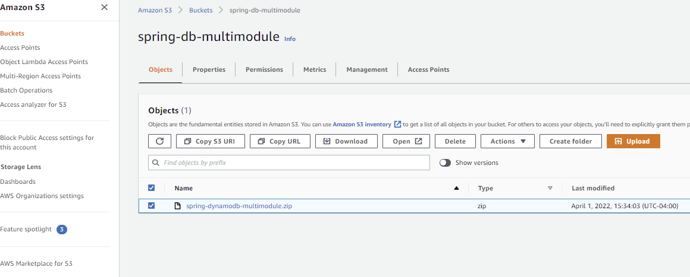

Select the checkbox for you previous zip file and select Delete to remove it. Type in delete in the confirmation screen for deletion.

Click on the Upload button to upload your modified application zip file to the S3 bucket.



Add the name of the modified spring boot application zip file to the Files and folder field.

Then Click upload to upload the zip file.

Click the Upload button at the bottom to actually start the upload.



Goto AWS Services, type in CodePipeline, and select the CodePipeline link.

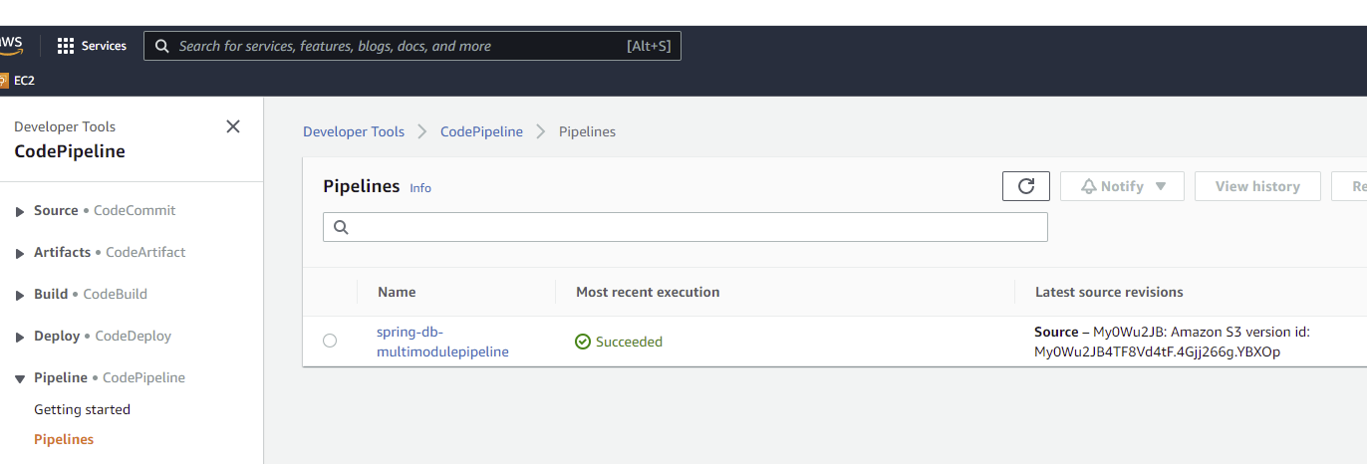

Select the link for you code pipeline. [The Most recent version will not be displaying Succeeded]

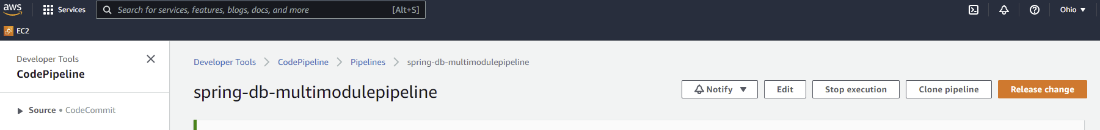

Click on the Release Change button on the right side of the page. This will start the process of checking the application zip file, and start the code deploy and code pipeline processes.

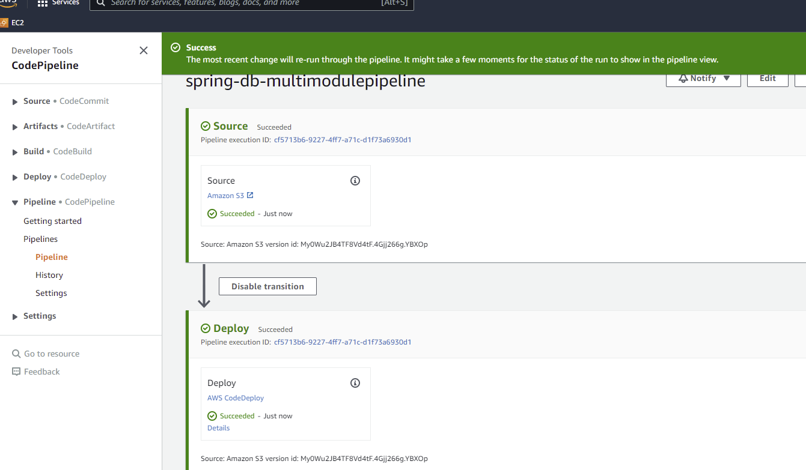

Select the Details link in the Deploy section to see if the re-deploy is successful. It will also give some information on the reason for the failure if that occurs.